Algebra Practice

Algebra Complete Examples
Integer Exponents

Rules;
0 rule
1 rule
Power to a power
Negative
Product
Quotient

Example 1
Simplify and write with positive exponents
a. ${\left(4x^{-4}y^{5}\right)}^{3}$
=$4x^{\left(-4\left(3\right)\right)}y^{\left(5\left(3\right)\right)}$
=$4x^{-12}y^{15}$
=$\frac{y^{15}}{x^{12}}$

b. ${\left(-10z^{2}y^{-4}\right)}^{2}{\left(z^{3}y\right)}^{-5}$
=$\left({\left(-10\right)}^{2}z^{\left(2\left(2\right)\right)}y^{\left(-4\left(2\right)\right)}\right)\left(z^{\left(3\left(-5\right)\right)}y^{-5}\right)$
=$\left(100z^{4}y^{-8}\right)\left(z^{-15}y^{-5}\right)$
=$100z^{\left(4+\left(-15\right)\right)}y^{\left(-8+\left(-5\right)\right)}$
=$100z^{-11}y^{-13}$
=$\frac{100}{y^{13}z^{13}}$

c. $\frac{n^{-2}m}{7m^{-4}n^{-3}}$
=7$m^{\left(1-\left(-3\right)\right)}n^{\left(-2-\left(-3\right)\right)}$
=7$m^{\left(1+3\right)}n^{\left(-2+3\right)}$
=7$m^{4}n^{1}$

d. $\frac{5x^{-1}y^{-4}}{{\left(3y^{5}\right)}^{-2}x^{9}}$
=$\frac{5x^{-1}y^{-4}}{3^{-2}y^{\left(5\left(-2\right)\right)}x^{9}}$
=$\frac{5x^{-1}y^{-4}}{3^{-2}y^{-10}x^{9}}$
=$\frac{5x^{-1}y^{-4}}{9^{-1}y^{-10}x^{9}}$
=$\left(9\right)\left(5\right)x^{\left(-1-9\right)}y^{\left(-4-\left(-10\right)\right)}$
=$45x^{\left(-10\right)}y^{\left(-4+10\right)}$
=$45x^{-10}y^{6}$
=$\frac{45y^{6}}{x^{10}}$

e. ${\left(\frac{z^{-5}}{z^{-2}x^{-1}}\right)}^{6}$
=${\left(z^{\left(-5-\left(-2\right)\right)}x^{1}\right)}^{6}$
=${\left(z^{\left(-5+2\right)}x^{1}\right)}^{6}$
=${\left(z^{-3}x^{1}\right)}^{6}$
=$z^{\left(-3\left(6\right)\right)}x^{\left(1\left(6\right)\right)}$
=$x^{6}z^{-18}$
=$\frac{x^{6}}{z^{18}}$

f. ${\left(\frac{24a^{3}b^{-8}}{6a^{-5}b}\right)}^{-2}$
=${\left(\frac{24}{6}a^{\left(3-\left(-5\right)\right)}b^{\left(-8-1\right)}\right)}^{-2}$
=${\left(4a^{\left(3+5\right)}b^{\left(-9\right)}\right)}^{-2}$
=${\left(4a^{8}b^{-9}\right)}^{-2}$
=$4a^{\left(8\left(-2\right)\right)}b^{\left(-9\left(-2\right)\right)}$
=$4a^{-16}b^{18}$
=$\frac{4b^{18}}{a^{16}}$

Simplify each to leave only positive exponents
a. ${25}^{\frac{1}{2}}$
=${\left(5^{2}\right)}^{\frac{1}{2}}$
=5

b. ${32}^{\frac{1}{5}}$
=${\left(2^{5}\right)}^{\frac{1}{5}}$
=2

c. ${81}^{\frac{1}{4}}$
$={\left(3^{4}\right)}^{\frac{1}{4}}$
=3

d. ${\left(-8\right)}^{\frac{1}{3}}$
=${{\left(-1\right)}^{\frac{1}{3}}\left(2\right)}^{\frac{1}{3}}$
=${\left(-1\right)}^{\frac{1}{3}}{\left(2^{3}\right)}^{\frac{1}{3}}$
=$\left(-1\right)\left(2\right)$
=$-2$

e. ${\left(-16\right)}^{\frac{1}{4}}$
=${\left(-1\right)}^{\frac{1}{4}}{\left(16\right)}^{\frac{1}{4}}$
=${\left(-1\right)}^{\frac{1}{4}}{\left(2^{4}\right)}^{\frac{1}{4}}$
=${\left(-1\right)}^{\frac{1}{4}}{\left(2^{4}\right)}^{\frac{1}{4}}$
=${\left(-1\right)}^{\frac{1}{4}}\left(2\right)$

f. ${-16}^{\frac{1}{4}}$
=$\left(-\right){\left(2^{4}\right)}^{\frac{1}{4}}$
=$\left(-\right)\left(2\right)$
= $-2$

Example 2
Evaluate each of the following
a. $8^{\frac{2}{3}}$
=${\left(2^{3}\right)}^{\frac{2}{3}}$
=$2^{2}$
=4

b. ${625}^{\frac{3}{4}}$
=${\left(5^{4}\right)}^{\frac{3}{4}}$
=$5^{3}$
=125

c. ${\left(\frac{243}{32}\right)}^{\frac{4}{5}}$
=$\frac{{243}^{\frac{4}{5}}}{{32}^{\frac{4}{5}}}$
=$\frac{{\left(3^{5}\right)}^{\frac{4}{5}}}{{\left(2^{5}\right)}^{\frac{4}{5}}}$
=$\frac{{\left(3\right)}^{4}}{{\left(2\right)}^{4}}$
=$\frac{81}{16}$

Example 3
Simplify and write with positive exponents
a. ${\left(\frac{w^{-2}}{16v^{\frac{1}{2}}}\right)}^{\frac{1}{4}}$
=$\frac{w^{\left(-2*\frac{1}{4}\right)}}{{16}^{\frac{1}{4}} v^{\left(\frac{1}{2}*\frac{1}{4}\right)}}$
=$\frac{w^{-\frac{2}{4}}}{2v^{\frac{1}{8}}}$
=$\frac{w^{-\frac{1}{2}}}{2v^{\frac{1}{8}}}$
=$\frac{1}{2v^{\frac{1}{8}}w^{\frac{1}{2}}}$

b. ${\left(\frac{x^{2}y^{-\frac{2}{3}}}{x^{-\frac{1}{2}}y^{-3}}\right)}^{-\frac{1}{7}}$
=${\left(x^{\left(2-\left(-\frac{1}{2}\right)\right)}y^{\left(\left(-\frac{2}{3}\right)-\left(-3\right)\right)}\right)}^{-\frac{1}{7}}$
=${\left(x^{\left(\frac{4}{2}+\frac{1}{2}\right)}y^{\left(\left(-\frac{2}{3}\right)+\frac{9}{3}\right)}\right)}^{-\frac{1}{7}}$
=${\left(x^{\frac{5}{2}}y^{\frac{7}{3}}\right)}^{-\frac{1}{7}}$
=$x^{\left(\left(\frac{5}{2}\right)\left(-\frac{1}{7}\right)\right)}y^{\left(\frac{7}{3}\left(-\frac{1}{7}\right)\right)}$
=$x^{\left(-\frac{5}{14}\right)}y^{\left(-\frac{7}{21}\right)}$
=$\frac{1}{x^{\left(-\frac{5}{14}\right)}y^{\left(-\frac{7}{21}\right)}}$

Radicals
Example 1
Write each in exponent form
a. $\sqrt[4]{16}$
$={16}^{\frac{1}{4}}$
=${\left(2^{4}\right)}^{\frac{1}{4}}$
=2

b. $\sqrt[10]{8x}$
=${\left(8x\right)}^{\frac{1}{10}}$

c. $\sqrt{x^{2}+ y^{2}}$
=${\left(x^{2}+ y^{2}\right)}^{\frac{1}{2}}$

Example 2
Evaluate
$a.\left(i\right)$ $\sqrt{16}$
=${16}^{\frac{1}{2}}$
=${\left(4^{2}\right)}^{\frac{1}{2}}$
=4

$a.\left(ii\right)$ $\sqrt[4]{16}$
=${16}^{\frac{1}{4}}$
=${\left(2^{4}\right)}^{\frac{1}{4}}$
=2

b. $\sqrt[5]{243}$
=${243}^{\frac{1}{5}}$
=${\left(3^{5}\right)}^{\frac{1}{5}}$
=3

c. $\sqrt[4]{1296}$
=${1296}^{\frac{1}{4}}$
=${\left(6^{4}\right)}^{\frac{1}{4}}$
=6

d. $\sqrt[3]{-125}$
=${{\left(-1\right)}^{\frac{1}{5}}\left(125\right)}^{\frac{1}{5}}$
= ${{\left(-1\right)}^{\frac{1}{5}}\left(5^{5}\right)}^{\frac{1}{5}}$
=$\left(-1\right)\left(5\right)$
=$-5$

e. $\sqrt[4]{-16}$
=${\left({-16}^{4}\right)}^{\frac{1}{4}}$
=${\left(\left(-1\right)2^{4}\right)}^{\frac{1}{4}}$
=${\left(-1\right)}^{\frac{1}{4}}\left(2\right)$

Example 3
Simplify, assume all variables are positive
a. $\sqrt{y^{7}}$
=$\sqrt{{\left(y^{3}\right)}^{2}\left(y\right)}$
=$y^{3}\left(\sqrt{y}\right)$

b. $\sqrt[9]{x^{6}}$
=$x^{\frac{6}{9}}$
=$x^{\frac{2}{3}}$
=$\sqrt[3]{x^{2}}$

c. $\sqrt{18x^{6}y^{11}}$
=$\sqrt{\left(9\right)\left(2\right){\left(x^{3}\right)}^{2}{\left(y^{5}\right)}^{2}\left(y\right)}$
=$\sqrt{\left(3^{2}\right)\left(2\right){\left(x^{3}\right)}^{2}{\left(y^{5}\right)}^{2}\left(y\right)}$
=3$x^{3}y^{5}\left(\sqrt{2y}\right)$

d. $\sqrt[4]{32x^{9}y^{5}z^{12}}$
=$\sqrt[4]{\left(16\right)\left(2\right){\left(x^{4}\right)}^{2}\left(x\right){\left(y\right)}^{4}\left(y\right){\left(z^{3}\right)}^{4}}$
= $\sqrt[4]{{\left(2\right)}^{4}\left(2\right){\left(x^{4}\right)}^{2}\left(x\right){\left(y\right)}^{4}\left(y\right){\left(z^{3}\right)}^{4}}$
=2xyz$\left(\sqrt[4]{2xy}\right)$

e. $\sqrt[5]{x^{12}y^{4}z^{24}}$
=$\sqrt[5]{{\left(x^{2}\right)}^{5}{\left(x\right)}^{2}\left(y^{4}\right){\left(z^{4}\right)}^{5}\left(z^{4}\right)}$
=$x^{2}z^{4}\left(\sqrt[5]{x^{2}y^{4}z^{4}}\right)$

f. $\sqrt[3]{9x^{2}}\sqrt[3]{6x^{2}}$
=$\sqrt[3]{\left(9\right)\left(6\right)x^{\left(2+2\right)}}$
=$\sqrt[3]{54x^{4}}$
=$\sqrt[3]{\left(27\right)\left(2\right)x^{3}\left(x\right)}$
=3x$\left(\sqrt[3]{2x}\right)$

Example 4
Multiply each. Assume x is positive
a. $\left(\sqrt{x}+2\right)\left(\sqrt{x}-5\right)$
=$\left(\sqrt{x}\right)\left(\sqrt{x}\right)+\left(\sqrt{x}\right)\left(-5\right)+\left(2\right)\left(\sqrt{x}\right)+\left(2\right)\left(-5\right)$
=$\sqrt{\left(x\right)\left(x\right)}-5\sqrt{x}+2\sqrt{x}-10$
=$\sqrt{x^{2}}+\left(-5+2\right)\sqrt{x}-10$
= x$-$3$\sqrt{x}-$10

b. $\left(3\sqrt{x}-\sqrt{y}\right)\left(2\sqrt{x}-5\sqrt{y}\right)$
=$\left(3\sqrt{x}\right)\left(2\sqrt{x}\right)+\left(3\sqrt{x}\right)\left(-5\sqrt{y}\right)+\left(-\sqrt{y}\right)\left(2\sqrt{x}\right)+\left(-\sqrt{y}\right)\left(-5\sqrt{y}\right)$
=$\left(3\right)\left(2\right)\left(\sqrt{\left(x\right)\left(x\right)}\right)+\left(3\right)\left(-5\right)\sqrt{\left(x\right)\left(y\right)}+\left(2\right)\left(-\sqrt[\left(\right)]{\left(x\right)\left(y\right)}\right)+\left(-5\right)\left(\sqrt{\left(y\right)\left(y\right)}\right)$
=$6\sqrt{x^{2}}+\left(-15\sqrt{xy}+\left(-2\sqrt{xy}\right)\right)-5\sqrt{y^{2}}$
=$6x+\left(-15-2\right)\sqrt{xy}-5y$
=$6x-17\sqrt{xy}-5y$

c. $\left(5\sqrt{x}+2\right)\left(5\sqrt{x}-2\right)$
=${\left(5\sqrt{x}\right)}^{2} - {\left(2\right)}^{2}$
=$25x-4$

Example 5
Rationalize the denominator
a. $\frac{4}{\sqrt{x}}$
=$\left(\frac{4}{\sqrt{x}}\right)\left(\frac{\sqrt{x}}{\sqrt{x}}\right)$
=$\frac{4\left(\sqrt{x}\right)}{\sqrt{x}\left(\sqrt{x}\right)}$
=$\frac{4\left(\sqrt{x}\right)}{x}$

b. $\sqrt[5]{\frac{2}{x^{3}}}$
=$\frac{\sqrt[5]{2}}{\sqrt[5]{x^{3}}}$
=$\frac{2^{\frac{1}{5}}}{x^{\frac{3}{5}}}$
=$\left(\frac{2^{\frac{1}{5}}}{x^{\frac{3}{5}}}\right)\left(\frac{x^{\frac{2}{5}}}{x^{\frac{2}{5}}}\right)$
=$\frac{\left(2^{\frac{1}{5}}\right)\left(x^{\frac{2}{5}}\right)}{x^{\left(\frac{3}{5}+\frac{2}{5}\right)}}$
=$\frac{\sqrt[5]{2x^{2}}}{x}$

c. $\frac{1}{3-\sqrt{x}}$
=$\left(\frac{1}{3-\sqrt{x}}\right)\left(\frac{3+\sqrt{x}}{3+\sqrt{x}}\right)$
=$\frac{3+\sqrt{x}}{9-x}$

d. $\frac{5}{4\sqrt{x}+\sqrt{3}}$
=$\left(\frac{5}{4\sqrt{x}+\sqrt{3}}\right)\left(\frac{4\sqrt{x}-\sqrt{3}}{4\sqrt{x}-\sqrt{3}}\right)$
=$\frac{\left(5\right)\left(4\sqrt{x}-\sqrt{3}\right)}{\left(4\sqrt{x}+\sqrt{3}\right)\left(4\sqrt{x}-\sqrt{3}\right)}$
=$\frac{\left(5\right)\left(4\sqrt{x}-\sqrt{3}\right)}{16x-3}$
=$\frac{20\sqrt{x}-5\sqrt{3}}{16x-3}$

Polynomials
Example 1
a. add $6x^{5}-10x^{2}+x-45$ to $13x^{2}-9x+4$
$\left(13x^{2}-9x+4\right)+\left(6x^{5}-10x^{2}+x-45\right)$
=$6x^{5}+\left(13-10\right)x^{2}+\left(9-1\right)x+\left(4-45\right)$
=$6x^{5}+3x^{2}-8x-41$

b. subtract $5x^{3}-9x^{2}+x-3$ from $x^{2}+x+1$
=$\left(x^{2}+x+1\right)-\left(5x^{3}-9x^{2}+x-3\right)$
=$\left(x^{2}+x+1\right)+\left(-5x^{3}+9x^{2}-x+3\right)$
=$-5x^{3}+\left(1+9\right)x^{2}+\left(1-1\right)x+\left(1+3\right)$
=$-5x^{3}+10x^{2}+4$

Example 2
Multiply the following
a. $4x^{2}\left(x^{2}-6x+2\right)$
$=\left(4x^{2}\right)\left(x^{2}\right)-\left(4x^{2}\right)\left(6x\right)+\left(4x^{2}\right)\left(2\right)$
=$4x^{4}-24x^{3}+8x^{2}$

b. $\left(3x+5\right)\left(x-10\right)$
=$\left(3x\right)\left(x\right)+\left(3x\right)\left(-10\right)+\left(5\right)\left(x\right)+\left(5\right)\left(-10\right)$
=3$x^{2}-30x+5x-50$
=3$x^{2}-25x-50$

c. $\left(4x^{2}-x\right)\left(6-3x\right)$
=$\left(4x^{2}\right)\left(6\right)+\left(4x^{2}\right)\left(-3x\right)+\left(-x\right)\left(6\right)+\left(-x\right)\left(-3x\right)$
=$24x^{2}-12x^{3}-6x+3x^{2}$
=$\left(24+3\right)x^{2}-12x^{3}-6x$
=$27x^{2}-12x^{3}-6x$
=$-12x^{3}+27x^{2}-6x$

d. $\left(3x+7y\right)\left(x-2y\right)$
=$\left(3x\right)\left(x\right)+\left(3x\right)\left(-2y\right)+\left(7y\right)\left(x\right)+\left(7y\right)\left(-2y\right)$
=$3x^{2}-6xy+7xy-14y^{2}$
=$3x^{2}+\left(-6+7\right)xy-14y^{2}$
=$3x^{2}+xy-14y^{2}$

e. $\left(2x+3\right)\left(x^{2}-x+1\right)$
$=\left(2x\right)\left(x^{2}\right)+\left(2x\right)\left(-x\right)+\left(2x\right)\left(1\right)+\left(3\right)\left(x^{2}\right)+\left(3\right)\left(-x\right)+\left(3\right)\left(1\right)$
=$2x^{3}-2x^{2}+2x+3x^{2}-3x+\left(3\right)\left(1\right)$
=$2x^{3}+\left(-2+3\right)x^{2}+\left(2-3\right)x+3$
=2$x^{3}+x^{2}-x+3$

Example 3
Multiply the following
a. $\left(3x-5 \right)\left(3x+5 \right)$
=$\left({\left(3x\right)}^{2}-{\left(5\right)}^{2}\right)$
=$\left({9x}^{2}-25\right)$

b. ${\left(2x+6\right)}^{2}$
=${\left(2x\right)}^{2}+2\left(2x\right)\left(6\right)+{\left(6\right)}^{2}$
=${4x}^{2}+24x+36$

c. ${\left(1-7x \right)}^{2}$
=$1^{2}-2\left(1\right)\left(7x\right)+{\left(7x\right)}^{2}$
=$1-14x+49x^{2}$

d. ${4\left(x+3\right)}^{2}$
=4$\left(x^{2}+2\left(x\right)\left(3\right)+{\left(3\right)}^{2}\right)$
=4$\left(x^{2}+6x+9\right)$
=$\left(4\right)\left(x^{2}\right)+\left(4\right)\left(6x\right)+\left(4\right)\left(3\right)$
=$4x^{2}+24x+12$

Factoring Polynomials
Example 1
Factor out the greatest common factor
a. $8x^{4}-4x^{3}+10x^{2}$
=$2x^{2}\left(4x^{2}-2x+5\right)$

b. $x^{3}y^{2}+3x^{4}y+5x^{5}y^{3}$
$=x^{3}y\left(y+3x+5x^{2}y^{2}\right)$

c. 3$x^{6}-9x^{2}+3x$
=3x$\left(x^{5}-3x-1\right)$

d. $9x^{2}\left(2x+7\right)-12\left(2x+7\right)$
=$\left(2x+7\right)\left(9x^{2}-12\right)$
=$\left(2x+7\right)\left(3x\right)\left(3x-4\right)$
=$\left(3x\right)\left(3x-4\right)\left(2x+7\right)$

Example 2
Factor by grouping
a. 3$x^{2}-2x+12x-8$
=$\left(3x^{2}-2x\right)+\left(12x-8\right)$
=$x\left(3x-2\right)+4\left(3x-2\right)$
=$\left(x+4\right)\left(3x-2\right)$

b. $x^{5}+x-2x^{4}-2$
=$\left(x^{5}+x\right)+\left(-2x^{4}-2\right)$
=x$\left(x^{4}+1\right)+\left(-2\right)\left(x^{4}-1\right)$
=$\left(x-2\right)\left(x^{4}+1\right)$

c. $x^{5}-3x^{3}-2x^{2}+6$
=$\left(x^{5}-3x^{3}\right)+\left(-2x^{2}+6\right)$
=$x^{3}\left(x^{2}-3\right)+\left(-2\right)\left(x^{2}-3\right)$
=$\left(x^{3}-2\right)\left(x^{2}-3\right)$

Example 3
Factor the following
- $x^{2}+2x-15$
=$\left(x-3\right)\left(x+5\right)$

- $x^{2}-10x+24$
=$\left(x-6\right)\left(x-4\right)$

- $x^{2}+6x+9$
=$\left(x+3\right)\left(x+3\right)$
=${\left(x+3\right)}^{2}$

- $x^{2}+5x+1$
$x=\frac{-\left(b\right)±\sqrt{b^{2}-4ac}}{2a}$

- 3$x^{2}+2x-8$
=$\left(3x-4\right)\left(x+2\right)$

- 5$x^{2}-17x$+6
=$\left(5x-2\right)\left(x-3\right)$

- 4$x^{2}+10x-6$
=$\left(4x-2\right)\left(x+3\right)$
=$\left(2\right)\left(2x-1\right)\left(x+3\right)$

Special Forms
Example 4
- $x^{2}-20x+100$
=${\left(x-10\right)}^{2}$

- $25x^{2}-9$
=$\left(5x-3\right)\left(5x+3\right)$

- $8x^{3}+1$
=${\left(2x\right)}^{3}+{\left(1\right)}^{3}$
=$\left(2x+1\right)\left({\left(2x\right)}^{2}+2\left(2x\right)\left(1\right)+{\left(1\right)}^{2}\right)$
=$\left(2x+1\right)\left({4x}^{2}-2x+1\right)$

Example 5
Polynomials of degree greater than 2
Special Forms
$a^{2}+2ab+b^{2}= {\left(a+b\right)}^{2}$
$a^{2}-2ab+b^{2}= {\left(a-b\right)}^{2}$
$a^{2}-b^{2}= \left(a+b\right)\left(a-b\right)$
$a^{3}+b^{3}= \left(a+b\right)\left(a^{2}-ab+b^{2}\right)$
$a^{3}-b^{3}= \left(a-b\right)\left(a^{2}+ab+b^{2}\right)$

a. $3x^{4}-3x^{3}-36x^{2}$
=$\left(3x^{2}\right)\left(x^{2}-x-12\right)$
=$\left(3x^{2}\right)\left(x-4\right)\left(x+3\right)$

b. $x^{4}-25$
=$\left(x^{2}-5\right)\left(x^{2}+5\right)$

c. $x^{4}+x^{2}-20$
if $x^{2}=a$
$→ x^{4}+x^{2}-20= a^{2}+a-20$
=$\left(a+5\right)\left(a-4\right)$
$→ x^{4}+x^{2}-20= \left(x^{2}+5\right)\left(x^{2}-4\right)$
=$\left(x^{2}+5\right)\left(x^{2}-4\right)$
=$\left(x^{2}+5\right)\left(x-2\right)\left(x+2\right)$

Rational Expressions
Pdf page 47
Example 1
Reduce to lowest terms
a. $\frac{x^{2}-2x-8}{x^{2}-9x+20}$
=$\frac{\left(x-4\right)\left(x+2\right)}{ \left(x-4\right)\left(x-5\right)}$
=$\frac{\left(x+2\right)}{\left(x-5\right)}$

b. $\frac{x^{2}-25}{5x-x^{2}}$
=$\frac{ \left(x-5\right)\left(x+5\right)}{x\left(5-x\right)}$
=$\frac{ \left(x-5\right)\left(x+5\right)}{x\left(-\left(-5+x\right)\right)}$
=$\frac{ \left(x-5\right)\left(x+5\right)}{x\left(-1\right)\left(-5+x\right)}$
=$\frac{ \left(x-5\right)\left(x+5\right)}{-x\left(x-5\right)}$
=$\frac{x+5}{-x}$
=$-\frac{x+5}{x}$

c. $\frac{x^{7}+2x^{6}+x^{5}}{x^{3}{\left(x+1\right)}^{8}}$
=$\frac{x^{5}\left(x^{2}+2x+1\right)}{x^{3}{\left(x+1\right)}^{8}}$
=$\frac{\left(x^{2}\right)\left(x^{3}\right){\left(x+1\right)}^{2}}{x^{3}{\left(x+1\right)}^{8}}$
=$\frac{\left(x^{2}\right)\left(x^{3}\right){\left(x+1\right)}^{2}}{x^{3}{\left(x+1\right)}^{2}{\left(x+1\right)}^{6}}$
=$\frac{x^{2}}{{\left(x+1\right)}^{6}}$

Example 2
a. $\frac{x^{2}-5x-14}{x^{2}-3x+2}* \frac{x^{2}-4}{x^{2}-14x+49}$
=$\frac{\left(x-7\right)\left(x+2\right)\left(x+2\right)\left(x-2\right)}{\left(x-2\right)\left(x-1\right)\left(x-7\right)\left(x-7\right)}$
=$\frac{\left(x-7\right)\left(x-2\right)\left(x+2\right)\left(x+2\right)}{\left(x-7\right)\left(x-2\right)\left(x-1\right)\left(x-7\right)}$
=$\frac{\left(x+2\right)\left(x+2\right)}{\left(x-1\right)\left(x-7\right)}$
=$\frac{{\left(x+2\right)}^{2}}{\left(x-1\right)\left(x-7\right)}$

b. $\frac{m^{2}-9}{m^{2}+5m+6} / \frac{3-m}{m+2}$
=$\frac{\left(m-3\right)\left(m+3\right)}{\left(m+2\right)\left(m+3\right)}*\frac{\left(m+2\right)}{\left(3-m\right)}$
=$\frac{\left(m-3\right)\left(m+3\right)\left(m+2\right)}{\left(m+2\right)\left(m+3\right)\left(3-m\right)}$
=$\frac{\left(m-3\right)\left(m+3\right)\left(m+2\right)}{\left(m+2\right)\left(m+3\right)\left(-1\right)\left(-3+m\right)}$
=$\frac{\left(m-3\right)\left(m+3\right)\left(m+2\right)}{\left(m-3\right)\left(m+3\right)\left(m+2\right)\left(-1\right)}$
=$\frac{1}{-1}$
=$-1$
c. $\frac{y^{2}+5y+4}{\frac{y^{2}-1}{y+5}}$
=$\frac{y^{2}+5y+4}{1}/\frac{y^{2}-1}{y+5}$
=$\frac{y^{2}+5y+4}{1}*\frac{y+5}{y^{2}-1}$
=$\frac{y^{2}+5y+4\left(y+5\right)}{y^{2}-1}$
=$\frac{\left(y+1\right)\left(y+4\right)\left(y+5\right)}{\left(y+1\right)\left(y-1\right)}$
=$\frac{\left(y+4\right)\left(y+5\right)}{\left(y-1\right)}$
Example 3
a. $\frac{4}{6x^{2}}- \frac{1}{3x^{2}}- \frac{5}{2x^{3}}$ $→lcd is 6x^{3}$
=$\frac{4\left(x\right)}{6x^{2}\left(x\right)}-\frac{1\left(2x\right)}{3x^{2}\left(2x\right)}- \frac{5\left(3\right)}{2x^{3}\left(3\right)}$
=$\frac{4x-2x-15}{6x^{3}}$

b. $\frac{2}{z+1}- \frac{z-1}{z+2}$ $→lcd is \left(z+1\right)\left(z+2\right)$
=$\frac{2\left(z+2\right)}{\left(z+1\right)\left(z+2\right)}- \frac{z-1\left(z+1\right)}{\left(z+2\right)\left(z+1\right)}$
=$\frac{2\left(z+2\right)-\left(z-1\right)\left(z+1\right)}{\left(z+1\right)\left(z+2\right)}$
=$\frac{2\left(z+2\right)-\left(z-1\right)\left(z+1\right)}{\left(z+1\right)\left(z+2\right)}$
=$\frac{2z+4-\left(z^{2}-1\right)}{z^{2}+2z+z+2}$
=$\frac{2z+4+\left(-z^{2}+1\right)}{z^{2}+3z+2}$
=$\frac{2z+4-z^{2}+1}{z^{2}+3z+2}$
=$\frac{-z^{2}+2z+5}{z^{2}+3z+2}$
=$\frac{-\left(z^{2}-2z-5\right)}{z^{2}+3z+2}$
=$-\frac{z^{2}-2z-5}{\left(z+1\right)\left(z+2\right)}$

c. $\frac{y}{y^{2}-2y+1}-\frac{2}{y-1}+ \frac{3}{y+2}$
=$\frac{y}{\left(y-1\right)\left(y-1\right)}-\frac{2}{y-1}+ \frac{3}{y+2}$ $→lcd is \left(y-1\right)\left(y-1\right)\left(y+2\right)$

=$\frac{y\left(y+2\right)}{\left(y-1\right)\left(y-1\right)\left(y+2\right)}-\frac{2\left(y+2\right)\left(y-1\right)}{y-1\left(y+2\right)\left(y-1\right)}+ \frac{3\left(y-1\right)\left(y-1\right)}{y+2\left(y-1\right)\left(y-1\right)}$
=$\frac{\left(y\left(y+2\right)\right)-\left(2\left(y+2\right)\left(y-1\right)\right)+\left(3\left(y-1\right)\left(y-1\right)\right)}{\left(y-1\right)\left(y-1\right)\left(y+2\right)}$
=$\frac{\left(y^{2}+2y\right)-\left(2\left(y^{2}+y-2\right)\right)+\left(3\left(y^{2}-2y+1\right)\right)}{\left(y-1\right)\left(y-1\right)\left(y+2\right)}$
=$\frac{\left(y^{2}+2y\right)-\left(2y^{2}+2y-2\right)+\left(3y^{2}-6y+3\right)}{\left(y-1\right)\left(y-1\right)\left(y+2\right)}$
=$\frac{y^{2}+2y-2y^{2}-2y+2+3y^{2}-6y+3}{\left(y-1\right)\left(y-1\right)\left(y+2\right)}$
=$\frac{\left(1-2+3\right)y^{2}+\left(2-2-6\right)y+\left(2+3\right)}{\left(y-1\right)\left(y-1\right)\left(y+2\right)}$
=$\frac{-4y^{2}-6y+5}{\left(y-1\right)\left(y-1\right)\left(y+2\right)}$

d. $\frac{2x}{x^{2}-9}- \frac{1}{x+3}-\frac{2}{x-3}$ $→lcd is \left(x-3\right)\left(x+3\right)$
=$\frac{2x}{\left(x-3\right)\left(x+3\right)}- \frac{1}{x+3}-\frac{2}{x-3}$
=$\frac{2x}{\left(x-3\right)\left(x+3\right)}- \frac{1\left(x-3\right)}{x+3\left(x-3\right)}-\frac{2\left(x+3\right)}{x-3\left(x+3\right)}$
=$\frac{2x-\left(x-3\right)-\left(2\left(x+3\right)\right)}{\left(x-3\right)\left(x+3\right)}$
=$\frac{2x-\left(x-3\right)-\left(2x+6\right)}{\left(x-3\right)\left(x+3\right)}$
=$\frac{2x-x+3-2x-6}{\left(x-3\right)\left(x+3\right)}$
=$\frac{\left(2-1-2\right)x+\left(3-6\right)}{\left(x-3\right)\left(x+3\right)}$
=$\frac{-x-3}{\left(x-3\right)\left(x+3\right)}$
=$-\frac{x+3}{\left(x-3\right)\left(x+3\right)}$
=$-\frac{1}{x-3}$

e. $\frac{4}{y+2}- \frac{1}{y}+1$ $→lcd is y\left(y+2\right)$
=$\frac{4y}{y\left(y+2\right)}-\frac{\left(y+2\right)}{y\left(y+2\right)}+\frac{y\left(y+2\right)}{y\left(y+2\right)}$
=$\frac{4y-\left(y+2\right)+y\left(y+2\right)}{y\left(y+2\right)}$
=$\frac{4y-\left(y+2\right)+y^{2}+2y}{y\left(y+2\right)}$
=$\frac{4y-y-2+y^{2}+2y}{y\left(y+2\right)}$
=$\frac{y^{2}+\left(4-1+2\right)y-2}{y\left(y+2\right)}$
=$\frac{y^{2}+5y-2}{y\left(y+2\right)}$

Complex Numbers
Pdf page 58
Example 1
Write in standard form
a. $\left(-4+7i\right)+\left(5-10i\right)$
=$-4+5+7i-10i$
=$1-3i$

b. $\left(4+12i\right)-\left(3-15i\right)$
=$4+12i-3+15i$
=$4-3+12i+15i$
=1+27i

c. $5i-\left(-9+i\right)$
=$5i+9-i$
=$9+5i-i$
=$9+4i$

Example 2
Write in standard form
a. $7i\left(-5+2i\right)$
=$-35i+14i^{2}$
=$-35i+14\left(-1\right)$
=$-35i-14$
=$-14+35i$

b. $\left(1-5i\right)\left(-9+2i\right)$
=$\left(1\right)\left(-9\right)+\left(1\right)\left(2i\right)+\left(-5i\right)\left(-9\right)+\left(-5i\right)\left(2i\right)$
=$-9+2i+45i-10i^{2}$
=$-9+47i-10\left(-1\right)$
=$-9+47i+10$
=$-9+10+47i$
=$1+47i$

c. $\left(4+i\right)\left(2+3i\right)$
=$\left(4\right)\left(2\right)+\left(4\right)\left(3i\right)+\left(i\right)\left(2\right)+\left(i\right)\left(3i\right)$
=$8+12i+2i+3i^{2}$
=$8+14i+\left(3\right)\left(-1\right)$
=$8-3+14i$
=$5+14i$

d. $\left(1-8i\right)\left(1+8i\right)$
=$\left(1^{2}-{\left(8i\right)}^{2}\right)$
=$1-64\left(i^{2}\right)$
=$1—\left(-64\right)$
=65

Example 3
Write in standard form
a. $\frac{3-i}{2+7i}$
=$\frac{3-i\left(2-7i\right)}{2+7i\left(2-7i\right)}$
=$\frac{\left(3\right)\left(2\right)+\left(3\right)\left(-7i\right)+\left(-i\right)\left(2\right)+\left(-i\right)\left(-7i\right)}{{\left(2\right)}^{2}-{\left(7i\right)}^{2}}$
=$\frac{6-21i-2i+7\left(i^{2}\right)}{4-49\left(i^{2}\right)}$
=$\frac{6-21i-2i+7\left(-1\right)}{4-\left(49\right)\left(-1\right)}$
=$\frac{6-23i-7}{4+49}$
=$\frac{6-7-23i}{53}$
=$\frac{-1-23i}{53}$
=$-\frac{1}{53}-\frac{23}{53}i$

b. $\frac{3}{9-i}$
=$\frac{3\left(9+i\right)}{9-i\left(9+i\right)}$
=$\frac{27+3i}{9^{2}-i^{2}}$
=$\frac{27+3i}{{\left(9\right)}^{2}-\left(-1\right)}$
=$\frac{27+3i}{81+1}$
=$\frac{27+3i}{81+1}$
=$\frac{27+3i}{81+1}$
=$\frac{27+3i}{82}$
=$\frac{27}{82}+\frac{3i}{82}$
=$\frac{27}{82}+\frac{3}{82}i$

c. $\frac{8i}{1+2i}$
=$\frac{8i\left(1-2i\right)}{1+2i\left(1-2i\right)}$
=$\frac{8i-16\left(i^{2}\right)}{{\left(1\right)}^{2}-{\left(2i\right)}^{2}}$
=$\frac{8i-16\left(-1\right)}{1-4\left(i^{2}\right)}$
=$\frac{8i+16}{1-4\left(-1\right)}$
=$\frac{8i+16}{1+4}$
=$\frac{8i+16}{5}$
=$\frac{8i}{5}+\frac{16}{5}$
=$\frac{8i}{5}+\frac{16}{5}$
=$\frac{16}{5}+\frac{8}{5}i$

d. $\frac{6-9i}{2i}$
=$\frac{\left(6-9i\right)\left(2i\right)}{2i\left(2i\right)}$
=$\frac{12i-18\left(i^{2}\right)}{4\left(i^{2}\right)}$
=$\frac{12i-18\left(-1\right)}{4\left(-1\right)}$
=$\frac{12i+18}{-4}$
=$\frac{12i}{-4}+\frac{18}{-4}$
=$-\frac{18}{4}-\frac{12i}{4}$
=$-\frac{9}{2}-3i$
Example 4
Multiply and write in standard form
a. $\left(2-\sqrt{-100}\right)\left(1+\sqrt{-36}\right)$
=$\left(2-10i\right)\left(1+6i\right)$
=$\left(2\right)\left(1\right)+\left(2\right)\left(6i\right)+\left(-10i\right)\left(1\right)+\left(-10i\right)\left(6i\right)$
=$2+12i-10i-60\left(i^{2}\right)$
=$\left(12i-10i\right)+2-60\left(-1\right)$
=$2i+\left(2+60\right)$
=$2i$+62
=$62+2i$
Solving Equations and Inequalities
Pdf page 64

Example 1
Show that each of the following numbers are solutions to the given equations or inequalities
a. $x=3 in x^{2}-9=0$
$\left(3^{2}\right)-9=0$
$9-9=0 therefore 3 satisfies x^{2}-9=0$

b. $y=8 in 3\left(y+1\right)=4y-5$
$3\left(\left(8\right)+1\right)=4\left(8\right)-5$
$3\left(9\right)=32-5$
$27=27 therefore 8 satisfies 3\left(\left(8\right)+1\right)=4\left(8\right)-5$

c. $z=1 in 2\left(z-5\right)≤z$
$2\left(1-5\right)≤1$
$2\left(-4\right)≤1$
$-8≤1 therefore 1 satisfies 2\left(z-5\right)≤z$
$\left\{z|z≤1\right\}$

d. $z=-5 in 2\left(z-5\right)≤z$
$2\left(-5-5\right)≤-5$
$2\left(-10\right)≤-5$
$-20≤-5 therefore -5 satisfies 2\left(z-5\right)≤z$
$\left\{z|z≤5\right\}$

Example 2
Show the following numbers are not solutions the given equations or inequalities
a. $y=-2 in 3\left(y+1\right)=4y-5$
$3\left(\left(-2\right)+1\right)=4\left(-2\right)-5$
$2\left(-2\right)=\left(-8\right)-5$
$-4=40 therefore-2 does not satisfy 3\left(y+1\right)=4y-5$

b. $z=-12 in 2\left(z-5\right)≤4z$
$2\left(\left(-12\right)-5\right)≤4\left(-12\right)$
$2\left(-17\right)≤-48$
$-34≤-48 therefore-12 does not satisfiy 2\left(z-5\right)≤4z$

Linear Equations
Pdf page 70
Solve the following for the unknown variable
a. $3\left(x+5\right)=2\left(-6-x\right)-2x$
$3x+15=-12-2x-2x$
$3x+15=-12-4x$
$3x+4x=-12-15$
$7x=-27$
$x=-\frac{27}{7}$
$3\left(\left(-\frac{27}{7}\right)+5\right)=2\left(-6-\left(-\frac{27}{7}\right)\right)-2\left(-\frac{27}{7}\right)=true$

b. $\frac{m-2}{3}+1=\frac{2m}{7}$
$21\left(\frac{m-2}{3}+1\right)=\left(\frac{2m}{7}\right)21$
$7\left(m-2\right)+21=3\left(2m\right)$
$7m-14+21=6m$
$7m+7=6m$
$7=6m-7m$
$7=-1m$
$-7=m$
$\frac{\left(-7\right)-2}{3}+1=\frac{2\left(-7\right)}{7} =true$

c. $\frac{5}{2y-6}=\frac{10-y}{y^{2}-6y+9}$
$\frac{5}{2\left(y-3\right)}=\frac{10-y}{{\left(y-3\right)}^{2}}$
$\frac{5}{2\left(y-3\right)}\left(\frac{\left(y-3\right)}{\left(y-3\right)}\right)=\frac{10-y}{{\left(y-3\right)}^{2}}\left(\frac{2}{2}\right)$
$\frac{5\left(y-3\right)}{2{\left(y-3\right)}^{2}}=\frac{2\left(10-y\right)}{{2\left(y-3\right)}^{2}}$
$\left(2{\left(y-3\right)}^{2}\right)\frac{5y-15}{2{\left(y-3\right)}^{2}}=\frac{20-2y}{{2\left(y-3\right)}^{2}}\left(2{\left(y-3\right)}^{2}\right)$
$5y-15=20-2y$
$5y+2y=20+15$
$7y=35$
$y=5$
$\frac{5}{2\left(5\right)-6}=\frac{10-\left(5\right)}{{\left(5\right)}^{2}-6\left(5\right)+9}=true$

d. $\frac{2z}{z+3}=\frac{3}{z-10}+2$
$\left(\left(z-10\right)\left(z+3\right)\right)\left(\frac{2z}{z+3}\right)=\left(\frac{3}{z-10}+2\right)\left(\left(z-10\right)\left(z+3\right)\right)$
$\left(z-10\right)\left(2z\right)=3\left(z+3\right)+2\left(z-10\right)\left(z+3\right)$
$2z^{2}-20z=3z+9+2\left(z^{2}+3z-10z-30\right)$
$2z^{2}-20z=3z+9+2\left(z^{2}-7z-30\right)$
$2z^{2}-20z=3z+9+2z^{2}-14z-60$
$\left(2z^{2}-2z^{2}\right)+\left(-20z-3z+14z\right)=9-60$
$-9z=-51$
$z=\frac{51}{9}$
$z=\frac{17}{3}$
$\frac{2\left(\frac{17}{3}\right)}{\left(\frac{17}{3}\right)+3}=\frac{3}{\left(\frac{17}{3}\right)-10}+2=true$
Applications of linear equations
PDF page 77
Example 1
In a certain Algebra class there is a total of 350 possible points. These points come
from 5 homework sets that are worth 10 points each and 3 hour exams that are worth 100 points
each. A student has received homework scores of 4, 8, 7, 7, and 9 and the first two exam scores
are 78 and 83. Assuming that grades are assigned according to the standard scale and there are no
weights assigned to any of the grades is it possible for the student to receive an A in the class and
if so what is the minimum score on the third exam that will give an A? What about a B?
$$\frac{\left(points scored\right)}{\left(points possible\right)}=grade in tenths$$
$$let x=unknown exam score$$
For an A grade;
$$\frac{4+8+7+7+9+78+83+x}{350}=.9$$
$$\frac{196+x}{350}=.9$$
$$\left(\frac{196+x}{350}\right)\left(350\right)=\left(.9\right)\left(350\right)$$
$$196+x=315$$
$$196+x-196=315-196$$
$$x=119$$
For a B grade
$$\frac{4+8+7+7+9+78+83+x}{350}=.8$$
$$\frac{196+x}{350}=.8$$
$$\frac{196+x}{350}\left(350\right)=.8\left(350\right)$$
$$196+x=280$$
$$196+x-196=280-196$$
$$x=84$$

Example 2
We want to build a set of shelves. The width of the set of shelves needs to be 4
times the height of the set of shelves and the set of shelves must have three shelves in it. If there
are 72 feet of wood to use to build the set of shelves what should the dimensions of the set of
shelves be?
$$\left(\begin{aligned}amount of \\ wood used\end{aligned}\right)=\left(\begin{aligned}2 x height \\ of shevles\end{aligned}\right)+\left(\begin{aligned}number of \\ shelves\end{aligned}\right)\left(\begin{aligned}width of \\ shelves\end{aligned}\right)$$
$$if :width=4\left(height\right)$$
$$and let h=height$$
$$72 ft=2\left(h\right)+4\left(4h\right)$$
$$72=2h+16h$$
$$72=18h$$
$$\frac{72}{18}=\frac{18h}{18}$$
$$\frac{72}{18}=h$$
$$h=4 feet$$

Example 3
A calculator has been marked up 15% and is being sold for $78.50. How much did
the store pay the manufacturer of the calculator?
$$\left(\begin{aligned}markup \\ price\end{aligned}\right)=\left(\begin{aligned}markup \\ percentage\end{aligned}\right)\left(\begin{aligned}wholesale \\ price\end{aligned}\right)+\left(\begin{aligned}wholesale \\ price\end{aligned}\right)$$
$$let x=wholesale price$$
$$78.50=.15x+x$$
$$78.5=1.15x$$
$$\frac{78.5}{1.15}=\frac{1.15x}{1.15}$$
$$68.26≈x$$
$$x≈\$68.26$$

Example 4
A shirt is on sale for $15.00 and has been marked down 35%. How much was the
shirt being sold for before the sale?
$$\left(\begin{aligned}sale \\ price\end{aligned}\right)=\left(\begin{aligned}normal \\ price\end{aligned}\right)\left(100\%-\begin{aligned}markdown \\ percentage\end{aligned}\right)$$
$$let the normal price=x$$
$$15=x\left(1-.35\right)$$
$$15=.65x$$
$$\frac{15}{.65}=\frac{.65x}{.65}$$
$$23.08≈x$$
$$x≈\$23.08$$

Example 5
Two cars are 500 miles apart and moving directly towards each other. One car is moving at a speed of 100 mph and the other is moving at 70 mph. Assuming that the cars start moving at the same time how long does it take for the two cars to meet?
$$\left(\begin{aligned}total \\ miles\end{aligned}\right)=\left(\begin{aligned}speed of \\ car A\end{aligned}\right)\left(\begin{aligned}hours of \\ travel\end{aligned}\right)+\left(\begin{aligned}speed of \\ car B\end{aligned}\right)\left(\begin{aligned}hours of \\ travel\end{aligned}\right)$$
$$let h=the hours traveled by both cars$$
$$500 miles=\frac{100 miles}{1 hour}\left(h hours\right)+\frac{70 miles}{1 hour}\left(h hours\right)$$
$$500=\left(100+70\right)h$$
$$500=170h$$
$$\frac{500}{170}=\frac{170h}{170}$$
$$2.94≈h$$
$$h≈2.94 hours$$
Example 6
Repeat the previous example except this time assume that the faster car will start 1 hour after slower car starts.
$$\left(\begin{aligned}total \\ miles\end{aligned}\right)=\left(\begin{aligned}speed of \\ car A\end{aligned}\right)\left(\begin{aligned}hours of \\ travel\end{aligned}\right)+\left(\begin{aligned}speed of \\ car B\end{aligned}\right)\left(\begin{aligned}hours of \\ travel\end{aligned}\right)$$
$$500 miles=\frac{100 miles}{1 hour}\left(h-1\right)+\frac{70 miles}{1 hour}h$$

$$500=100\left(h-1\right)+70h$$

$$500=100h-100+70h$$

$$500=170h-100$$

$$500+100=170h-100+100$$
$$600=170h$$

$$\frac{600}{170}=\frac{170h}{170}$$

$$3.53 hours≈h$$

Example 7
Two boats start out 100 miles apart and start moving to the right at the same time. The boat on the left is moving at twice the speed as the boat on the right. Five hours after starting the boat on the left catches up with the boat on the right. How fast was each boat moving?

$$\left(\begin{aligned}speed of \\ boat on left\end{aligned}\right)\left(\begin{aligned}hours \\ traveled\end{aligned}\right)=\left(\begin{aligned}miles \\ traveled\end{aligned}\right)=\left(\begin{aligned}speed of \\ boat on right\end{aligned}\right)\left(\begin{aligned}hours \\ traveled\end{aligned}\right)+\left(\begin{aligned}100 \\ miles\end{aligned}\right)$$

$$let s=speed of boat on the right$$

$$\left(2s\right)\left(5 hours\right)=s\left(5 hours\right)+100$$

$$10s=5s+100$$

$$10s-5s=5s+100-5s$$

$$5s=100$$

$$\frac{5s}{5}=\frac{100}{5}$$

$$s=20 hours$$

Example 8
An office has two envelope stuffing machines. Machine A can stuff a batch of envelopes in 5 hours, while Machine B can stuff a batch of envelopes in 3 hours. How long would it take the two machines working together to stuff a batch of envelopes?

$$\left(\begin{aligned}rate of \\ machine A\end{aligned}\right)+\left(\begin{aligned}rate of \\ machine B\end{aligned}\right)=\frac{1 job}{hours}$$
$$let h equal the hours for 1 batch$$
$$\frac{1 batch}{3 hours}+\frac{1 batch}{5 hours}=\frac{1 batch}{h hours}$$
$$\frac{1}{3}+\frac{1}{5}=\frac{1}{h}$$
$$\frac{5}{15}+\frac{3}{15}=\frac{1}{h}$$
$$\frac{8}{15}=\frac{1}{h}$$
$$\frac{8}{15}\left(15h\right)=\frac{1}{h}\left(15h\right)$$
$$8h=15$$
$$\frac{8h}{8}=\frac{15}{8}$$
$$h=\frac{15}{8}hours=1.875 hours$$

Example 9
Mary can clean an office complex in 5 hours. Working together John and Mary can clean the office complex in 3.5 hours. How long would it take John to clean the office complex by himself?
$$\left(\begin{aligned}work rate \\ of Mary\end{aligned}\right)+\left(\begin{aligned}work rate \\ of John\end{aligned}\right)=\frac{1 job}{3.5 hours}$$

$$let h be the number of hours for john to clean 1 office$$

$$\frac{1}{5}+\frac{1}{h}=\frac{1}{3.5}$$

$$\left(\frac{1}{5}+\frac{1}{h}\right)\left(5*3.5*h\right)=\frac{1}{3.5}\left(5*3.5*h\right)$$

$$3.5h+\left(5*3.5\right)=5h$$

$$3.5h+17.5-3.5h=5h-3.5h$$

$$17.5=1.5h$$

$$\frac{17.5}{1.5}=\frac{1.5h}{1.5}$$

$$11.7 hours ≈h$$

Example 10
How much of a 50% alcohol solution should we mix with 10 gallons of a 35% solution to get a 40% solution?
$$\left(volume A\right)\left(x\%\right)+\left(volume B\right)\left(y\%\right)=\left(volume C\right)\left(z\%\right)$$

$$let x=volume of the 35\% solution in gallons$$
$$let x+10=volume of 40\% solution in gallons$$

$$x\left(.5\right)+10\left(.35\right)=\left(x+10\right)\left(.4\right)$$

$$.5x+3.5=.4x+4$$

$$.5x-.4x=4-3.5$$

$$.1x=.5$$

$$\frac{.1x}{.1}=\frac{.5}{.1}$$

$$x=5 gallons$$

Example 11
We have a 40% acid solution and we want 75 liters of a 15% acid solution. How much water should we put into the 40% solution to do this?

$$\left(\begin{aligned}amount of acid \\ in water\end{aligned}\right)+\left(\begin{aligned}amount of acid \\ in 40\% solution\end{aligned}\right)=\left(\begin{aligned}amount of acid \\ in 15\% solution\end{aligned}\right)$$

$$\left(0\right)\left(\begin{aligned}volume of \\ water\end{aligned}\right)+\left(.4\right)\left(\begin{aligned}volume of \\ solution\end{aligned}\right)=\left(75\right)\left(.15\right)$$

$$let x=volume of water solution in liters$$
$$let 75-x=volume of the 40\% solution in liters$$

Equations with more than one variable
PDF page 87
Process for solving linear equations;
1. Multiply both sides by the LCD to clear out any fractions.
2. Simplify both sides as much as possible to clear out parenthesis and combine like terms.
3. Move all terms containing the variable being solved for to one side, and all other terms to the opposite side.
4. Get a single instance of the variable being solved for in the equation. For these systems this will always be accomplished by factoring the variable out of each term.
5. Divide by the coefficient of the variable.
Example 1 Solve A = P(1+ rt ) for r.
$$A=P\left(1+rt\right)$$
$$A=P+Prt$$
$$\left(A\right)-P=\left(P+Prt\right)-P$$
$$A-P=Prt$$
$$\frac{A-P}{Pt}=\frac{Prt}{Pt}$$
$$\frac{A-P}{Pt}=r$$
$$\frac{A}{Pt}-\frac{P}{Pt}=r$$
$$\frac{A}{Pt}-\frac{1}{t}=r$$
$$r=\frac{A}{Pt}-\frac{1}{t}$$

Example 2 Solve $V=m\left(\frac{1}{b}-\frac{5aR}{m}\right)$ for R.
$$V=m\left(\frac{1}{b}-\frac{5aR}{m}\right)$$

$$V=\frac{m}{b}-\frac{5aRm}{m}$$
$$V=\frac{m}{b}-5aR$$

$$\left(V\right)\left(b\right)=\left(\frac{m}{b}-5aR\right)\left(b\right)$$

$$Vb=m-5aRb$$

$$\left(Vb\right)-m=\left(m-5aRb\right)-m$$

$$Vb-m=-5aRb$$

$$\frac{Vb-m}{-5ab}=\frac{-5aRb}{-5ab}$$

$$\frac{Vb-m}{-5ab}=R$$

$$\frac{Vb-m}{\left(-1\right)5ab}=R$$

$$\left(-1\right)\left(\frac{Vb-m}{5ab}\right)=R$$

$$\frac{\left(-1\right)\left(Vb-m\right)}{5ab}$$

$$\frac{-Vb+m}{5ab}=R$$

$$\frac{m-Vb}{5ab}=R$$

$$R=\frac{m-Vb}{5ab}$$

Example 3 Solve $V=m\left(\frac{1}{b}-\frac{5aR}{m}\right)$ for $b$
$$V=m\left(\frac{1}{b}-\frac{5aR}{m}\right)$$
$$V=\frac{m}{b}-5aR$$
$$\left(V\right)\left(b\right)=\left(\frac{m}{b}-5aR\right)\left(b\right)$$
$$Vb=m-5aRb$$
$$\left(Vb\right)-m=\left(m-5aRb\right)-m$$
$$Vb-m=-5aRb$$
$$\frac{Vb-m}{-5aR}=\frac{-5aRb}{-5aR}$$
$$\frac{Vb-m}{-5aR}=b$$
$$\frac{Vb-m}{\left(-1\right)5aR}=b$$
$$\left(-1\right)\frac{Vb-m}{5aR}=b$$
$$\frac{\left(-1\right)\left(Vb-m\right)}{5aR}=b$$
$$\frac{-Vb+m}{5aR}=b$$
$$\frac{m-Vb}{5aR}=b$$
Example 4 Solve $\frac{1}{a}=\frac{1}{b}+\frac{1}{c}$ for $c$
$$\frac{1}{a}=\frac{1}{b}+\frac{1}{c}$$
$$\left(\frac{1}{a}\right)\left(abc\right)=\left(\frac{1}{b}+\frac{1}{c}\right)\left(abc\right)$$
$$bc=ac+ab$$
$$\left(bc\right)-ac=\left(ac+ab\right)-ac$$
$$bc-ac=ab$$
$$c\left(b-a\right)=ab$$
$$\frac{c\left(b-a\right)}{b-a}=\frac{ab}{b-a}$$
$$c=\frac{ab}{b-a}$$

Example 5 Solve $y=\frac{4}{5x-9}$ for $x$
$$y=\frac{4}{5x-9}$$
$$\left(y\right)\left(5x-9\right)=\left(\frac{4}{5x-9}\right)\left(5x-9\right)$$
$$5xy-9y=4$$
$$\left(5xy-9y\right)+9y=\left(4\right)+9y$$
$$5xy=4+9y$$
$$\frac{5xy}{5y}=\frac{4+9y}{5y}$$
$$x=\frac{4+9y}{5y}$$
$$x=\frac{4}{5y}+\frac{9y}{5y}$$
$$x=\frac{4}{5}y+\frac{9}{5}$$

Example 6 Solve $y=\frac{4-3x}{1+8x}$ for $x$
$$\left(y\right)\left(1+8x\right)=\left(\frac{4-3x}{1+8x}\right)\left(1+8x\right)$$
$$y+8xy=4-3x$$
$$\left(y+8xy\right)+3x=\left(4-3x\right)+3x$$
$$y+8xy+3x=4$$
$$\left(y+8xy+3x\right)-y=\left(4\right)-y$$
$$8xy+3x=4-y$$
$$x\left(8y+3\right)=4-y$$
$$\frac{x\left(8y+3\right)}{8y+3}=\frac{4-y}{8y+3}$$
$$x=\frac{4-y}{8y+3}$$

Quadratic equations – Part I
PDF page 91
Four Methods of solving quadratic equations;
1. Solving by factoring
For $ax^{2}+bx+c=0$
$$if ab=0 →a=0 or b=0$$
Example 1
a.
$$x^{2}-x=12$$
$$\left(x^{2}-x\right)-12=\left(12\right)-12$$
$$x^{2}-x-12=0$$
$$\left(x-4\right)\left(x+3\right)=0$$
$x-4=0$ $x+3=0$
$\left(x-4\right)+4=\left(0\right)+4$ $\left(x+3\right)-3=\left(0\right)-3$
$x=4$ $x=-3$
b.
$x^{2}+40=-14$
$\left(x^{2}+40\right)+14=\left(-14\right)+14$
$x^{2}+40+14x=0$
$x^{2}+14x+40=0$
$\left(x+10\right)\left(x+4\right)=0$
$x+10=0$ $x+4=0$
$x=-10$ $x=-4$

c.
$y^{2}+12y+36=0$
$\left(y+6\right)\left(y+6\right)$
$y+6=0$
$y=-6$

d.
$4m^{2}-1=0$
$$\left(2m-1\right)\left(2m+1\right)=0$$
$2m-1=0$ $2m+1=0$
$2m=1$ $2m=-1$
$\frac{2m}{2}=\frac{1}{2}$ $\frac{2m}{2}=\frac{-1}{2}$
$m=\frac{1}{2}$ $m=-\frac{1}{2}$
e.
$$3x^{2}=2x+8$$
$$\left(3x^{2}\right)-\left(2x+8\right)=\left(2x+8\right)-\left(2x+8\right)$$
$$3x^{2}-2x-8=0$$
$$\left(3x+4\right)\left(x-2\right)=0$$
$3x+4=0$ $x-2=0$
$3x=-4$ $x=2$
$\frac{3x}{3}=\frac{-4}{3}$
$x=-\frac{4}{3}$
f.
$$10z^{2}+19z+6=0$$
$$\left(5z+2\right)\left(2z+3\right)=0$$
$5z+2=0$ $2z+3=0$
$5z=-2$ $2z=-3$
$\frac{5z}{5}=\frac{-2}{5}$ $\frac{2z}{2}=\frac{-3}{2}$
$z=-\frac{2}{5}$ $z=-\frac{3}{2}$

g.
$5x^{2}=2x$
$5x^{2}-2x=0$
$x\left(5x-2\right)=0$
$5x-2=0$ $x=0$
$5x=2$
$\frac{5x}{5}=\frac{2}{5}$
$x=\frac{2}{5}$

Example 2
a.
$$\frac{1}{x+1}=1-\frac{5}{2x-4}$$
$$\left(\frac{1}{x+1}\right)\left(x+1\right)\left(2x-4\right)=\left(1-\frac{5}{2x-4}\right)\left(x+1\right)\left(2x-4\right)$$
$$2x-4=\left(x+1\right)\left(2x-4\right)-5\left(x+1\right)$$
$$2x-4=2x^{2}-4x+2x-4-5x-5$$
$$2x-4=2x^{2}+\left(-4x+2x-5x\right)+\left(-4-5\right)$$
$$2x-4=2x^{2}-7x-9$$
$$\left(2x-4\right)-\left(2x-4\right)=\left(2x^{2}-7x-9\right)-\left(2x-4\right)$$
$$0=2x^{2}-7x-9-2x+4$$
$$0=2x^{2}+\left(-7x-2x\right)+\left(-9+4\right)$$
$$0=2x^{2}-9x-5$$
$$0=\left(2x+1\right)\left(x-5\right)$$
$2x+1=0$ $x-5=0$
$2x=-1$ $x=5$
$\frac{2x}{2}=\frac{-1}{2}$
$x=-\frac{1}{2}$

b.
$$x+3+\frac{3}{x-1}=\frac{4-x}{x-1}$$
$$\left(x+3\right)+\frac{3}{x-1}=\frac{4-x}{x-1}$$
$$\left(x+3\right)\left(x-1\right)+\left(\frac{3}{x-1}\right)\left(x-1\right)=\left(\frac{4-x}{x-1}\right)\left(x-1\right)$$
$$x^{2}-x+3x-3+3=4-x$$
$$x^{2}+\left(-x+3x\right)+\left(-3+3\right)=4-x$$
$$x^{2}+2x=4-x$$
$$\left(x^{2}+2x\right)-\left(4-x\right)=\left(4-x\right)-\left(4-x\right)$$
$$x^{2}+2x-\left(4-x\right)=0$$
$$x^{2}+2x-4+x=0$$
$$x^{2}+\left(2x+x\right)-4=0$$
$$x^{2}+3x-4=0$$
$$\left(x-1\right)\left(x+4\right)=0$$
$x-1=0$ $x+4=0$
$x=1$ $x=-4$
But because $\frac{3}{x-1}$ for 1 is $\frac{3}{0}$, 1 in not a solution

Example 3
a.
$$5x^{3}-5x^{2}-10=0$$
$$5x\left(x^{2}-x-2\right)$$
$$\left(5x\right)\left(x+1\right)\left(x-2\right)$$
$5x=0$ $x+1=0$ $x-2=0$
$x=0$ $x=-1$ $x=2$
The second method of salving quadratics uses the square root property
If $p^{2}=d$ then $p=±\sqrt{d}$
Example 4
a.
$$x^{2}-100=0$$
$$x^{2}=100$$
$$x=±10$$
b.
$$25y^{2}-3=0$$
$$25y^{2}=3$$
$$\frac{25y^{2}}{25}=\frac{3}{25}$$
$$y^{2}=\frac{3}{25}$$
$$y=±\sqrt{\frac{3}{25}}$$
$$y=±\frac{\sqrt{3}}{\sqrt{25}}$$
$$y=±\frac{\sqrt{3}}{5}$$

c.
$$4z^{2}+49=0$$
$$4z^{2}=-49$$
$$\frac{4z^{2}}{4}=\frac{-49}{4}$$
$$z^{2}=\frac{-49}{4}$$
$$z=±\sqrt{\frac{-49}{4}}$$
$$z=±\frac{7\sqrt{-1}}{2}$$
$$z=±\frac{7}{2}i$$

d.
$${\left(2t-9\right)}^{2}=5$$
$$2t-9=±\sqrt{5}$$
$$2t=9±\sqrt{5}$$
$$\frac{2t}{2}=\frac{9±\sqrt{5}}{2}$$
$$t=\frac{9±\sqrt{5}}{2}$$
$$t=\frac{9}{2}±\frac{\sqrt{5}}{2}$$
e.
$${\left(3x+10\right)}^{2}+81=0$$
$$let u=\left(3x+10\right)$$
$$u^{2}+81=0$$
$$u^{2}=-81$$
$$u=±\sqrt{-81}$$
$$u=±9i$$
$$3x+10=±9i$$
$3x+10=-9i$ $3x+10=9i$
$3x=-10-9i$ $3x=-10+9i$
$\frac{3x}{3}=\frac{-10-9i}{3}$ $\frac{3x}{3}=\frac{-10+9i}{3}$
$x=-\frac{10}{3}-\frac{9}{3}i$ $x=-\frac{10}{3}+\frac{9}{3}i$
$x=-\frac{10}{3}-3i$ $x=-\frac{10}{3}+3i$
$$3x+\frac{10}{3}±3i$$

Quadratic Equations Part II
PDF page 99
How to complete the square;
For $x^{2}+bx$
Add ${\left(\frac{b}{2}\right)}^{2}$
Resulting in $x^{2}+bx+{\left(\frac{b}{2}\right)}^{2}$
And when factored equals ${\left(x+\frac{b}{2}\right)}^{2}$
Example 1, Complete the square
a. $x^{2}-16x$
$$x^{2}-16x$$
Add the following ${\left(\frac{-16}{2}\right)}^{2}$
$$x^{2}-16x+{\left(\frac{-16}{2}\right)}^{2}$$
$$x^{2}-16x+{\left(-8\right)}^{2}$$
$$x^{2}-16x+64$$
$$\left(x-8\right)\left(x-8\right)$$
$${\left(x-8\right)}^{2}$$

b. $y^{2}+7y$
$$y^{2}+7y$$
Add the following ${\left(\frac{7}{2}\right)}^{2}$
$$y^{2}+7y+{\left(\frac{7}{2}\right)}^{2}$$
$$y^{2}+7y+\frac{7^{2}}{2^{4}}$$
$$y^{2}+7y+\frac{49}{4}$$
$${\left(y+\frac{7}{2}\right)}^{2}$$

Example 2, Complete the square
a. $x^{2}-6x+1=0$
$$x^{2}-6x=-1$$
Add the square ${\left(\frac{-6}{2}\right)}^{2}$
$$x^{2}-6x+{\left(\frac{-6}{2}\right)}^{2}=-1+{\left(\frac{-6}{2}\right)}^{2}$$
$$x^{2}-6x+{\left(-3\right)}^{2}=-1+{\left(-3\right)}^{2}$$
$$x^{2}-6x+9=-1+9$$
$$x^{2}-6x+9=8$$
$${\left(x-3\right)}^{2}=8$$
$$x-3=\sqrt{8}$$

b. $2x^{2}+6x+7=0$
$$2x^{2}+6x+7=0$$
$$2x^{2}+6x=-7$$
$$2\left(x^{2}+3x\right)=-7$$
$$\frac{2\left(x^{2}+3x\right)}{2}=\frac{-7}{2}$$
$$x^{2}+3x=-\frac{7}{2}$$
Add the square ${\left(\frac{3}{2}\right)}^{2}$
$$x^{2}+3x+{\left(\frac{3}{2}\right)}^{2}=-\frac{7}{2}+{\left(\frac{3}{2}\right)}^{2}$$
$${\left(x+\frac{3}{2}\right)}^{2}=-\frac{7}{2}+\frac{3^{2}}{2^{2}}$$
$${\left(x+\frac{3}{2}\right)}^{2}=-\frac{7}{2}+\frac{9}{4}$$
$${\left(x+\frac{3}{2}\right)}^{2}=-\frac{14}{4}+\frac{9}{4}$$
$${\left(x+\frac{3}{2}\right)}^{2}=-\frac{5}{4}$$
$$x+\frac{3}{2}=\sqrt{-\frac{5}{4}}$$
$$x+\frac{3}{2}=±\sqrt{\left(-1\right)\frac{5}{4}}$$
$$x+\frac{3}{2}=±\frac{\sqrt{5}}{\sqrt{4}}$$
$$x+\frac{3}{2}=±\frac{\sqrt{5}}{2}i$$
$$x=-\frac{3}{2}±\frac{\sqrt{5}}{2}i$$

c. $3x^{2}-2x-1=0$
$$3x^{2}-2x-1=0$$
$$3x^{2}-2x=1$$
$$\frac{3x^{2}-2x}{3}=\frac{1}{3}$$
$$x^{2}-\frac{2}{3}x=\frac{1}{3}$$
$$add the square {\left(\frac{-\frac{2}{3}}{2}\right)}^{2}$$
$$={\left(\frac{1}{2}*-\frac{2}{3}\right)}^{2}$$
$${\left(-\frac{2}{6}\right)}^{2}$$
$${\left(-\frac{1}{3}\right)}^{2}$$
$$x^{2}-\frac{2}{3}x+{\left(-\frac{1}{3}\right)}^{2}=\frac{1}{3}+{\left(-\frac{1}{3}\right)}^{2}$$
$$x^{2}-\frac{2}{3}x+{\left(-\frac{1}{3}\right)}^{2}=\frac{1}{3}+\frac{1}{9}$$
$$x^{2}-\frac{2}{3}x+{\left(-\frac{1}{3}\right)}^{2}=\frac{3}{9}+\frac{1}{9}$$
$${\left(x-\frac{1}{3}\right)}^{2}=\frac{4}{9}$$
$$\sqrt{{\left(x-\frac{1}{3}\right)}^{2}}=±\sqrt{\frac{4}{9}}$$
$$x-\frac{1}{3}=±\frac{2}{3}$$
$$x=±\frac{2}{3}+\frac{1}{3}$$
$$x=\frac{1}{3}±\frac{2}{3}$$
$x=\frac{2}{3}+\frac{1}{3}$ $x=-\frac{2}{3}+\frac{1}{3}$
$x=\frac{3}{3}$ $x=-\frac{1}{3}$
$x=1$

Example 3, Use the quadratic formula to solve each equation
a. $x^{2}+2x=7$
$$x^{2}+2x=7$$
$$x^{2}+2x-7=0$$
$x=\frac{-\left(2\right)+\sqrt{2^{2}-4\left(1\right)\left(-7\right)}}{2\left(1\right)}$ $x=\frac{-\left(2\right)-\sqrt{2^{2}-4\left(1\right)\left(-7\right)}}{2\left(1\right)}$
$x=\frac{-2+\sqrt{32}}{2}$ $x=\frac{-2-\sqrt{32}}{2}$
$x=\frac{-2}{2}+\frac{\sqrt{32}}{2}$ $x=\frac{-2}{2}-\frac{\sqrt{32}}{2}$
$x=-1+\frac{\sqrt{16*2}}{2}$ $x=-1-\frac{\sqrt{16*2}}{2}$
$x=-1+\frac{4\sqrt{2}}{2}$ $x=-1-\frac{4\sqrt{2}}{2}$
$x=-1+2\sqrt{2}$ $x=-1-2\sqrt{2}$

b. $3q^{2}+11=5q$
$$3q^{2}+11=5q$$
$$3q^{2}+11-5q=0$$
$$3q^{2}-5q+11=0$$
$$x=\frac{-\left(-5\right)±\sqrt{{\left(-5\right)}^{2}-4\left(3\right)\left(11\right)}}{2\left(3\right)}$$
$x=\frac{5+\sqrt{-107}}{6}$ $x=\frac{5-\sqrt{-107}}{6}$
$x=\frac{5}{6}+\frac{\sqrt{107}}{6}i$ $x=\frac{5}{6}-\frac{\sqrt{107}}{6}i$

c. $7t^{2}=6-19t$
$$7t^{2}=6-19t$$
$$7t^{2}-\left(6-19t\right)=0$$
$$7t^{2}-6+19t=0$$
$$7t^{2}+19t-6=0$$

d. $\frac{3}{y-2}=\frac{1}{y}+1$
$$\frac{3}{y-2}=\frac{1}{y}+1$$
$$\left(\frac{3}{y-2}\right)\left(y\right)\left(y-2\right)=\left(\frac{1}{y}+1\right)\left(y\right)\left(y-2\right)$$
$$3y=y-2+\left(y\right)\left(y-2\right)$$
$$3y=y-2+y^{2}-2y$$
$$3y=y^{2}+\left(y-2y\right)-2$$
$$3y=y^{2}-y-2$$
$$0=y^{2}+\left(-y-3y\right)-2$$
$$y^{2}-4y-2=0$$
$$x=\frac{8±\sqrt{16+8}}{2}$$
$$x=\frac{8±\sqrt{24}}{2}$$
$$x=\frac{8±2\sqrt{6}}{2}$$
$$x=4±\sqrt{6}$$
$x=4+\sqrt{6}$ $x=4-\sqrt{6}$

e. $16x-x^{2}=0$
$$-x^{2}+16x=0$$
$$-x^{2}+16x+0=0$$
$$x=\frac{-\left(16\right)±\sqrt{{\left(16\right)}^{2}-4\left(-1\right)\left(0\right)}}{2\left(-1\right)}$$
$$x=\frac{-16±\sqrt{256}}{-2}$$
$$x=\frac{-16±16}{2}$$
$x=\frac{-16+16}{2}$ $x=\frac{-16-16}{2}$
$x=\frac{0}{2}$ $x=\frac{-32}{2}$
$x=0$ $x=-16$

Example 4, Solve
a. $\frac{1}{2}x^{2}+x-\frac{1}{10}=0$
$$x=\frac{-\left(1\right)±\sqrt{{\left(1\right)}^{2}-4\left(\frac{1}{2}\right)\left(-\frac{1}{10}\right)}}{2\left(\frac{1}{2}\right)}$$
$$x=\frac{-1±\sqrt{1.2}}{1}$$
$x=\frac{-1+\sqrt{1.2}}{1}$ $x=\frac{-1-\sqrt{1.2}}{1}$
$x=\frac{\sqrt{30}}{5}-1$ $x=\frac{\sqrt{30}}{5}+1$

b. $0.04x^{2}-0.23x+0.09=0$
$$x=\frac{-\left(-.23\right)±\sqrt{{\left(-.23\right)}^{2}-4\left(.04\right)\left(.09\right)}}{2\left(.04\right)}$$
$$x=\frac{.23±\sqrt{.0385}}{.08}$$
$x=\frac{.23+\sqrt{.0385}}{.08}$ $x=\frac{0.23-\sqrt[2]{0.0385}}{0.08}$
$x=\frac{\sqrt{385}+23}{8}$ $x=\frac{23-\sqrt{385}}{8}$

Quadratic Equations Summary
PDF Pg. 111
Example 1
Use the discriminant to determine the solution set
a. $13x^{2}+1=5x$
$$13x^{2}+1-5x=0$$
$$13x^{2}-5x+1=0$$
$$populate the discriminant {\left(b\right)}^{2}-4\left(a\right)\left(c\right)={\left(-5\right)}^{2}-4\left(13\right)\left(1\right)$$
$$25-52=-27$$
$$-27<0→there will be 2 complex roots$$

b. $6q^{2}+20q=3$
$$6q^{2}+20q-3=0$$
$$populate the discriminant {\left(b\right)}^{2}-4\left(a\right)\left(c\right)={\left(20\right)}^{2}-4\left(6\right)\left(-3\right)$$
$$=472$$
$$472>0→there will be 2 rational roots$$
c. $49t^{2}+126t+81=0$
$$populate the discriminant {\left(b\right)}^{2}-4\left(a\right)\left(c\right)={\left(126\right)}^{2}-4\left(49\right)\left(81\right)$$
$$=0$$
$$0=0→therefor there will be a double root$$

Applications of Quadratic Equations
PDF Page 113
Example 1 We are going to fence in a rectangular field and we know that for some reason we
want the field to have an enclosed area of 75 ft2. We also know that we want the width of the
field to be 3 feet longer than the length of the field. What are the dimensions of the field?
$$length*width=area$$
$$l*\left(l+3\right)=75 {ft}^{2}$$
$$l^{2}+3l=75$$
$$l^{2}+3l-75=0$$
$$l=\frac{-\left(3\right)±\sqrt{{\left(3\right)}^{2}-4\left(1\right)\left(-75\right)}}{2\left(1\right)}$$
$$l=\frac{-3±\sqrt{309}}{2}$$
$$l=\frac{-3±17.58}{2}$$
$l=\frac{-3+17.58}{2}$ $l=\frac{-3-17.58}{2}$
$l=7.29$ $l=-10.29$
$$the length of the field is 7.29 ft$$
$$the width of the field is 7.29+3=10.29 ft$$

Example 2 Two cars start out at the same point. One car starts out driving north at 25 mph.
Two hours later the second car starts driving east at 20 mph. How long after the first car starts
traveling does it take for the two cars to be 300 miles apart?
$$let t=time traveled$$
$$a^{2}+b^{2}=c^{2}$$
$${\left(\left(\begin{aligned}car A \\ speed\end{aligned}\right)\left(t\right)\right)}^{2}+{\left(\left(\begin{aligned}car B \\ speed\end{aligned}\right)\left(t-2\right)\right)}^{2}={300}^{2}$$
$${\left(25t\right)}^{2}+{\left(20\left(t-2\right)\right)}^{2}={300}^{2}$$
$$625t^{2}+{\left(20t-40\right)}^{2}=90000$$
$$625t^{2}+\left(20t-40\right)\left(20t-40\right)=90000$$
$$625t^{2}+{400t}^{2}-2\left(20t\right)\left(40\right)+{40}^{2}=90000$$
$$1025t^{2}-1600t+1600=90000$$
$$1025t^{2}-1600t+1600-90000=0$$
$$1025t^{2}-1600t-88400=0$$
$$t=\frac{-\left(-1600\right)±\sqrt{{\left(-1600\right)}^{2}-4\left(1025\right)\left(-88400\right)}}{2\left(1025\right)}$$
$$t=\frac{1600±\sqrt{365000000}}{2050}$$
$$t=\frac{1600±1000\sqrt{365}}{2050}$$
$$t=\frac{32±20\sqrt{365}}{41}$$
$t=\frac{32-20\sqrt{365}}{41}$ $t=\frac{32+20\sqrt{365}}{41}$
$t=-8.5390 hours$ $t=10.1 hours$

Example 3 An office has two envelope stuffing machines. Working together they can stuff a
batch of envelopes in 2 hours. Working separately, it will take the second machine 1 hour longer
than the first machine to stuff a batch of envelopes. How long would it take each machine to stuff
a batch of envelopes by themselves?
$$\left(\begin{aligned}batch rate of \\ machine A\end{aligned}\right)\left(\begin{aligned}hours \\ worked\end{aligned}\right)+\left(\begin{aligned}batch rate of \\ machine B\end{aligned}\right)\left(\begin{aligned}hours \\ worked\end{aligned}\right)=\frac{1 batch}{2 hours}$$
$$let t=hours worked by machine A to complete 1 batch$$
$$let t+1=hours worked by machine B to complete 1 batch$$
$$\frac{1}{t}+\frac{1}{t+2}=\frac{1}{2}$$
$$\left(\frac{1}{t}+\frac{1}{t+2}\right)\left(2\right)\left(t\right)\left(t+1\right)=\left(\frac{1}{2}\right)\left(2\right)\left(t\right)\left(t+1\right)$$
$$2\left(t+1\right)+2t=\left(t\right)\left(t+1\right)$$
$$2t+2+2t=t^{2}+t$$
$$t^{2}+t-\left(2t+2+2t\right)=0$$
$$t^{2}+t-2t-2-2t=0$$
$$t^{2}+\left(t-2t-2t\right)-2=0$$
$$t^{2}-3t-2=0$$
$$t=\frac{-\left(-3\right)±\sqrt{{\left(-3\right)}^{2}-4\left(1\right)\left(-2\right)}}{2\left(1\right)}$$
$$t=\frac{3±\sqrt{17}}{2}$$
$t=\frac{3-\sqrt{17}}{2}$ $t=\frac{3+\sqrt{17}}{2}$
$t=-0.56155 hours$ $t=3.5615 hours$
$$machine A needs 3.156 hours to complete 1 batch of envelopes$$
$$machine B needs t+1=3.156+1=4.156 hours to complete 1 batch of envelopes$$

Equations Reducible to Quadratic Form
PDF Page 117
Example 1, Solve $x^{4}-7x^{2}+12=0$
$$if u=x^{2}→x^{4}-7x^{2}+12=u^{2}-7u+12$$
$$u^{2}-7u+12=0$$
$$\left(u-3\right)\left(u-4\right)=0$$
$u-3=0$ $u-4=0$
$u=3$ $u=4$
$u=x^{2}=3$ $u=x^{2}=4$
$x^{2}=3$ $x^{2}=4$
$\sqrt{x^{2}}=\sqrt{3}$ $\sqrt[x]{x^{2}}=\sqrt{4}$
$x=\sqrt{3}$ $x=2$

Example 2, Solve Each
a. $x^{\frac{2}{3}}-2x^{\frac{1}{3}}-15=0$
$$if u=x^{\frac{1}{3}}→x^{\frac{2}{3}}-2x^{\frac{1}{3}}-15=u^{2}-2u-15$$
$$u^{2}-2u-15=0$$
$$\left(u-5\right)\left(u+3\right)=0$$
$u-5=0$ $u+3=0$
$u=5$ $u=-3$
$x^{\frac{1}{3}}=u=5$ $u=x^{\frac{1}{3}}=-3$
$x^{\frac{1}{3}}=5$ $x^{\frac{1}{3}}=-3$
$\sqrt[3]{x}=5$ $\sqrt[3]{x}=-3$
${\left(\sqrt[3]{x}\right)}^{3}=5^{3}=125=x$ ${\left(\sqrt[3]{x}\right)}^{3}={\left(-3\right)}^{3}=-81=x$
$${125}^{\frac{2}{3}}-(2){125}^{\frac{1}{3}}-15=0$$
$$25-2*5-15=0$$
$$25-25=0$$

$${(-81)}^{\frac{2}{3}}-(2{)(-81)}^{\frac{1}{3}}-15=0$$
$$9-\left(2\right)\left(-3\right)-15=0$$
$$9-\left(-6\right)-15=0$$
$$9+6-15=0$$
b. $y^{-6}-9y^{-3}+8=0$
$$if y^{-3}=u→y^{-6}-9y^{-3}+8=u^{2}-9u+8$$
$$u^{2}-9u+8=0$$
$$\left(u-1\right)\left(u-8\right)=0$$
$u-1=0$ $u-8=0$
$u=1$ $u=8$
$u=y^{-3}=1$ $u=y^{-3}=8$
$\frac{1}{y^{3}}=1$ $\frac{1}{y^{3}}=8$
$\left(y^{3}\right)\frac{1}{y^{3}}=1\left(y^{3}\right)$ $\left(y^{3}\right)\frac{1}{y^{3}}=8\left(y^{3}\right)$
$1=y^{3}$ 1$=8\left(y^{3}\right)$
$\sqrt[3]{1}=\sqrt[3]{y^{3}}$ $\frac{1}{8}=y^{3}$
$1=y$ $\sqrt[3]{\frac{1}{8}}=\sqrt[3]{y^{3}}$
$\frac{\sqrt[3]{1}}{\sqrt[3]{8}}=y$
$\frac{1}{2}=y$

c. $z-9\sqrt{z}+14=0$
$$if \sqrt{z}=u→z-9\sqrt{z}+14=u^{2}-9u+14$$
$$u^{2}-9u+14=0$$
$$\left(u-2\right)\left(u-7\right)=0$$
$u-2=0$ $u-7=0$
$u=2$ $u=7$
$u=\sqrt{z}=2$ $u=\sqrt{z}=7$
$\sqrt{z}=2$ $\sqrt{z}=7$
${\left(\sqrt{z}\right)}^{2}={\left(2\right)}^{2}$ ${\left(\sqrt{z}\right)}^{2}={\left(7\right)}^{2}$
$z=4$ $z=49$

$4-9\sqrt{4}+14=0$
$4-9\left(2\right)+14=0$
$4-18+14=0$
$-14+14=0$

$49-9\sqrt{49}+14=0$
$49-9\left(7\right)+14=0$
$49-63+14=0$
$-14+14=0$

d. $t^{4}-4=0$
$$t^{4}-4=\left(t^{2}-2\right)\left(t^{2}+2\right)$$
$t^{2}-2=0$ $t^{2}+2=0$
$t^{2}=2$ $t^{2}=-2$
$\sqrt{\left(t^{2}\right)}=\sqrt{2}$ $\sqrt{\left(t^{2}\right)}=\sqrt{-2}$
$t=\sqrt{2}$ $t=\sqrt{2}\left(i\right)$
${\left(\sqrt{2}\right)}^{4}-4=0$
${\left({\left(\sqrt{2}\right)}^{2}\right)}^{2}-4=0$
${\left(2\right)}^{2}-4=0$
$4-4=0$

${\left(\sqrt{2}\left(i\right)\right)}^{4}-4=0$
${\left({\left(\sqrt{-2}\right)}^{2}\right)}^{2}-4=0$
${\left(-2\right)}^{2}-4=0$
$4-4=0$

Example 3, Solve $2x^{10}-x^{5}-4=0$
$$if u=x^{5}→2x^{10}-x^{5}-4=2u^{2}-u-4$$
$$2u^{2}-u-4=0$$
$$u=\frac{-\left(-1\right)±\sqrt{{\left(-1\right)}^{2}-4\left(2\right)\left(-4\right)}}{2\left(2\right)}$$
$$u=\frac{1±\sqrt{33}}{4}$$
$u=\frac{1-\sqrt{33}}{4}$ $u=\frac{1+\sqrt{33}}{4}$
$u=x^{5}=\frac{1-\sqrt{33}}{4}$ $u=x^{5}=\frac{1+\sqrt{33}}{4}$
${\left(x^{5}\right)}^{\frac{1}{5}}={\left(\frac{1-\sqrt{33}}{4}\right)}^{\frac{1}{5}}$ ${\left(x^{5}\right)}^{\frac{1}{5}}={\left(\frac{1+\sqrt{33}}{4}\right)}^{\frac{1}{5}}$
$x=\sqrt[5]{\frac{1-\sqrt{33}}{4}}$ $x=\sqrt[5]{\frac{1+\sqrt{33}}{4}}$

Equations with Radicals
PDF Page 122
Example 1, Solve $x=\sqrt{x+6}$
$$x=\sqrt{x+6}$$
$$x^{2}={\left(\sqrt{x+6}\right)}^{2}$$
$$x^{2}=x+6$$
$$x^{2}-\left(x+6\right)=0$$
$$x^{2}-x-6=0$$
$$\left(x+2\right)\left(x-3\right)=0$$
$x+2=0$ $x-3=0$
$x=-2$ $x=3$

$-2=\sqrt{2+6}$
$-2≠\sqrt{8}$

$3=\sqrt{3+6}$
$3=\sqrt{9}$
$3=3$

Example 2, Solve the following equations
a. $y+\sqrt{y-4}=4$
$$y+\sqrt{y-4}=4$$
$$\sqrt{y-4}=4-y$$
$${\left(\sqrt{y-4}\right)}^{2}={\left(4-y\right)}^{2}$$
$$y-4=16-8y+y^{2}$$
$$16-8y+y^{2}-\left(y-4\right)=0$$
$$16-8y+y^{2}-y+4=0$$
$$y^{2}+\left(-8y-y\right)+\left(16+4\right)=0$$
$$y^{2}-9y+20=0$$
$$\left(y-5\right)\left(y-4\right)=0$$
$y-5=0$ $y-4=0$
$y=5$ $y=4$

$5+\sqrt{5-4}=4$
$5+\sqrt{1}=4$
$5+1=4$
$6≠4$

$4+\sqrt{4-4}=4$
$4+\sqrt{0}=4$
$4=4$

b. $1=t+\sqrt{2t-3}$
$$1=t+\sqrt{2t-3}$$
$$1-t=\sqrt{2t-3}$$
$${\left(1-t\right)}^{2}={\left(\sqrt{2t-3}\right)}^{2}$$
$$1-2t+t^{2}=2t-3$$
$$t^{2}-2t+1-\left(2t-3\right)=0$$
$$t^{2}-2t+1-2t+3=0$$
$$t^{2}+\left(-2t-2t\right)+\left(1+3\right)=0$$
$$t^{2}-4t+4=0$$
$${\left(t-2\right)}^{2}=0$$
$$t-2=0$$
$$t=2$$

$$1=2+\sqrt{2\left(2\right)-3}$$
$$1=2\sqrt{4-3}$$
$$1=2\sqrt{1}$$
$$1=2\left(1\right)$$
$$1≠2$$
$$no solution$$
c. $\sqrt{5z+6}-2=z$
$$\sqrt{5z+6}-2=z$$
$$\sqrt{5z+6}=z+2$$
$${\left(\sqrt{5z+6}\right)}^{2}={\left(z+2\right)}^{2}$$
$$5z+6=z^{2}+4z+4$$
$$z^{2}+4z+4-\left(5z+6\right)=0$$
$$z^{2}+4z+4-5z-6=0$$
$$z^{2}+\left(4z-5z\right)+\left(4-6\right)=0$$
$$z^{2}-z-2=0$$
$$\left(z+1\right)\left(z-2\right)=0$$

$z+1=0$ $z-2=0$
$z=-1$ $z=2$

$\sqrt{5\left(-1\right)+6}-2=\left(-1\right)$
$\sqrt{-5+6}-2=-1$
$\sqrt{1}-2=-1$
$1-2=-1$
$-1=-1$

$\sqrt{5\left(2\right)+6}-2=\left(2\right)$
$\sqrt{10+6}-2=2$
$\sqrt{16}-2=2$
$4-2=2$
$2=2$

Example 3, Solve the following equations
a. $\sqrt{2x-1}-\sqrt{x-4}=2$
$$\sqrt{2x-1}-\sqrt{x-4}=2$$
$$\sqrt{2x-1}=2+\sqrt{x-4}$$
$${\left(\sqrt{2x-1}\right)}^{2}={\left(2+\sqrt{x-4}\right)}^{2}$$
$$2x-1=\left(2+\sqrt{x-4}\right)\left(2+\sqrt{x-4}\right)$$
$$2x-1=4+4\sqrt{x-4}+x-4$$
$$2x-1=\left(4-4\right)+4\sqrt{x-4}+x$$
$$2x-1=4\sqrt{x-4}+x$$
$$2x-1-\left(x\right)=4\sqrt{x-4}$$
$$\left(2x-x\right)-1=4\sqrt{x-4}$$
$$x-1=4\sqrt{x-4}$$
$${\left(x-1\right)}^{2}={\left(4\sqrt{x-4}\right)}^{2}$$
$$x^{2}-2x+1=16\left(x-4\right)$$
$$x^{2}-2x+1=16x-64$$
$$x^{2}-2x+1-\left(16x-64\right)=0$$
$$x^{2}-2x+1-16x+64=0$$
$$x^{2}+\left(-2x-16x\right)+\left(1+64\right)=0$$
$$x^{2}-18x+65=0$$
$$\left(x-5\right)\left(x-13\right)=0$$
$x-5=0$ $x-13=0$
$x=5$ $x=13$

$\sqrt{2\left(5\right)-1}-\sqrt{5-4}=2$
$\sqrt{10-1}-\sqrt{1}=2$
$\sqrt{9}-1=2$
$3-1=2$
$2=2$

$\sqrt{2\left(13\right)-1}-\sqrt{13-4}=2$
$\sqrt{26-1}-\sqrt{9}=2$
$\sqrt{25}-\sqrt{9}=2$
$5-3=2$
$2=2$

b. $\sqrt{t+7}+2=\sqrt{3-t}$
$$\sqrt{t+7}+2=\sqrt{3-t}$$
$${\left(\sqrt{t+7}+2\right)}^{2}={\left(3-t\right)}^{2}$$
$$t+7+2\left(2\right)\sqrt{t+7}+4=3-t$$
$$t+7+4\sqrt{t+7}+4=3-t$$
$$t+\left(7+4\right)+4\sqrt{t+7}=3-t$$
$$t+11+4\sqrt{t+7}=3-t$$
$$4\sqrt{t+7}=3-t-\left(t+11\right)$$
$$4\sqrt{t+7}=3-t-t-11$$
$$4\sqrt{t+7}=\left(3-11\right)+\left(-t-t\right)$$
$$4\sqrt{t+7}=-8-2t$$
$${\left(4\sqrt{t+7}\right)}^{2}={\left(-8-2t\right)}^{2}$$
$$16\left(t+7\right)=\left(-8-2t\right)\left(-8-2t\right)$$
$$16\left(t+7\right)=64+16t+16t+4t^{2}$$
$$16t+112=64+32t+4t^{2}$$
$$4t^{2}+32t+64-\left(16t+112\right)=0$$
$$4t^{2}+32t+64-16t-112=0$$
$$4t^{2}+\left(32t-16t\right)+\left(64-112\right)=0$$
$$4t^{2}+16t-48=0$$
$$\left(4t-8\right)\left(t+6\right)=0$$
$4t-8=0$ $t+6=0$
$4t=8$ $t=-6$
$t=\frac{8}{4}$
$t=2$

$\sqrt{2+7}+2=\sqrt{3-2}$
$\sqrt{9}+2=\sqrt{1}$
$±3+2=1$
$5≠1$
$-3+2=1$
$-1≠1$

$\sqrt{-6+7}+2=\sqrt{3-\left(-6\right)}$
$\sqrt{1}+2=\sqrt{3+6}$
$1+2=±\sqrt{9}$
$3=3$

Linear Inequalities
PDF Page 128
Example 1, Solving the following inequalities, give both the inequality and interval notation forms of the solution.
a. $-2\left(m-3\right)<5\left(m+1\right)-12$
$$-2m-\left(-6\right)<5m+5-12$$
$$-2m+6<5m-7$$
$$-2m-5m<-7-6$$
$$-7m<-13$$
$$m>\frac{-13}{-7}$$
$$m>\frac{13}{7}$$
$$\left(\frac{13}{7}, ∞\right)$$

b. $2\left(1-x\right)+5≤3\left(2x-1\right)$
$$2-2x+5≤6x-3$$
$$-2x+7≤6x-3$$
$$7+3≥6x+2x$$
$$10≥8x$$
$$\frac{10}{8}≥x$$
$$\frac{5}{4}≥x$$
$$[\frac{5}{4}, ∞)$$

Example 2, Solve each of the following inequalities. Give both the inequality and interval notation forms of the solution.
a. $-6≤2\left(x-5\right)<7$
$$-6≤2x-10<7$$
$$-6+10≤2x<7+10$$
$$4≤2x<17$$
$$\frac{4}{2}≤x<\frac{17}{2}$$
$$2≤x<\frac{17}{2}$$
$$[2, \frac{17}{2})$$

b. $-3<\frac{3}{2}\left(2-x\right)≤5$
$$-3<\left(\frac{3}{2}*2\right)-\frac{3}{2}x≤5$$
$$-3<\frac{6}{2}-\frac{3}{2}x≤5$$
$$-3<3-\frac{3}{2}x≤5$$
$$-3-3<-\frac{3}{2}x≤5$$
$$-6<-\frac{3}{2}x≤5$$
$$\frac{-6}{-\frac{3}{2}}>x≥\frac{5}{-\frac{3}{2}}$$
$$-6\left(-\frac{2}{3}\right)>x≥5\left(-\frac{2}{3}\right)$$
$$\frac{12}{3}>x≥-\frac{10}{3}$$
$$-\frac{10}{3}≤x<4$$
$$[-\frac{10}{3}, 4)$$

c. $-14<-7\left(3x+2\right)<1$
$$-14<-7\left(3x+2\right)<1$$
$$-14<-21x-14<1$$
$$-14+14<-21x<1+14$$
$$0<-21x<15$$
$$-\frac{0}{21}>x>-\frac{15}{21}$$
$$0>x>-\frac{15}{21}$$
$$-\frac{15}{21}<x<0$$
$$-\frac{5}{7}<x<0$$
$$\left(-\frac{5}{7}, 0\right)$$

Example 3, $if-1<x<4, then dermine a and b in a<2x+3<b$
$$2*\left(-1<x<4\right)$$
$$-2<2x<8$$
$$3+\left(-2<2x<8\right)$$
$$-2+3<2x+3<8+3$$
$$1<2x+3<11$$

Polynomial Inequalities
PDF Page 135

- $x^{2}-10<3x$
$$x^{2}-10<3x$$
$$x^{2}-10x-3x<0$$
$$\left(x-5\right)\left(x+2\right)<0$$
$$finding the roots$$
$x-5=0$ $x+2=0$
$x=5$ $-2=x$
$$test cases$$
$$if x_{1}=-3$$
$$=\left(-3-5\right)\left(-3+2\right)$$
$$=\left(-8\right)\left(-1\right)$$
$$=8$$

$$if x_{2}=0$$
$$=\left(0-5\right)\left(0+2\right)$$
$$=\left(-5\right)\left(2\right)$$
$$=-10$$

$$if x_{3}=6$$
$$=\left(6-5\right)\left(6+2\right)$$
$$=\left(1\right)\left(8\right)$$
$$=8$$

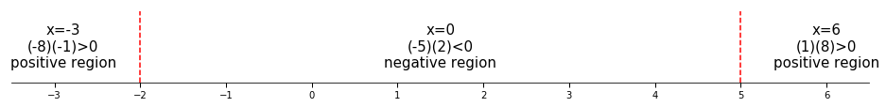
$$for x^{2}-10x-3x<0;$$
$$-2<x<5$$
$$(-2, 5)$$
- $x^{2}-5x≥-6$
$$x^{2}-5x≥-6$$
$$x^{2}-5x+6≥0$$
$$\left(x-2\right)\left(x-3\right)≥0$$
$$finding the roots$$
$x-2=0$ $x-3=0$
$x=2$ $x=3$
$$test cases$$
$$x_{1}=1$$
$$\left(1-2\right)\left(1-3\right)=$$
$$\left(-1\right)\left(-2\right)=$$
$$2$$

$$x_{2}=2.5$$
$$\left(2.5-2\right)\left(2.5-3\right)=$$
$$\left(.5\right)\left(-.5\right)=$$
$$-.25$$

$$x_{3}=4$$
$$\left(4-2\right)\left(4-3\right)=$$
$$\left(2\right)\left(1\right)=$$
$$2$$

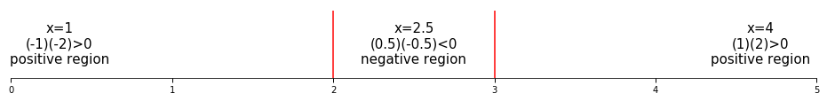

$$for x^{2}-5x+6≥0;$$
$$x≤2 \& 3≤x$$
$$\left(-∞, 2\right] \& [3, ∞)$$

- $x^{4}+4x^{3}-12x^{2}≤0$
$$x^{4}+4x^{3}-12x^{2}≤0$$
$$x^{2}\left(x^{2}+4x-12≤0\right)$$
$$\left(x^{2}\right)\left(x+6\right)\left(x-2\right)≤0$$

$$finding the roots$$
$x+6=0$ $x-2=0$ $x^{2}=0$
$x=-6$ $x=2$ $x=0$

$$test cases$$
$$x_{1}=-7$$
$$\left({\left(-7\right)}^{2}\right)\left(\left(-7\right)+6\right)\left(\left(-7\right)-2\right)=$$
$$\left(49\right)\left(-1\right)\left(-9\right)=$$
$$441$$

$$x_{2}=-3$$
$$\left({\left(-3\right)}^{2}\right)\left(\left(-3\right)+6\right)\left(\left(-3\right)-2\right)=$$
$$\left(9\right)\left(3\right)\left(-5\right)=$$
$$-135$$

$$x_{3}=1$$
$$\left({\left(1\right)}^{2}\right)\left(\left(1\right)+6\right)\left(\left(1\right)-2\right)=$$
$$\left(1\right)\left(7\right)\left(-1\right)$$
$$-7$$

$$x_{4}=3$$
$$\left({\left(3\right)}^{2}\right)\left(\left(3\right)+6\right)\left(\left(3\right)-2\right)=$$
$$\left(9\right)\left(9\right)\left(1\right)=$$
$$81$$
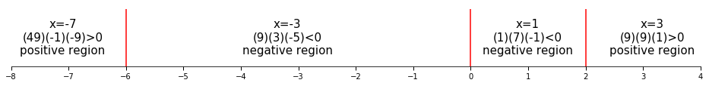

$$for \left(x^{2}\right)\left(x+6\right)\left(x-2\right)≤0$$
$$-6≤x≤2$$
$$[-6, 2]$$

- $\left(x+1\right){\left(x-3\right)}^{2}>0$
$$\left(x+1\right){\left(x-3\right)}^{2}>0$$
$$\left(x+1\right)\left(x-3\right)\left(x-3\right)>0$$

$$finding the roots$$
$x+1=0$ $x-3=0$
$x=-1$ $x=3$

$$test cases$$
$$x_{1}=-2$$
$$\left(\left(-2\right)+1\right)\left(\left(-2\right)-3\right)\left(\left(-2\right)-3\right)=$$
$$\left(-1\right)\left(-5\right)\left(-5\right)=$$
$$-25$$

$$x_{2}=1$$
$$\left(1+1\right)\left(1-3\right)\left(1-3\right)$$
$$\left(2\right)\left(-2\right)\left(-2\right)=$$
$$8$$

$$x_{3}=4$$
$$\left(4+1\right)\left(4-3\right)\left(4-3\right)=$$
$$\left(5\right)\left(1\right)\left(1\right)=$$
$$5$$

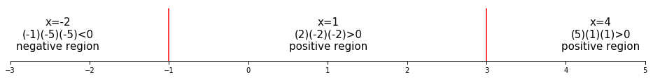

$$for \left(x+1\right)\left(x-3\right)\left(x-3\right)>0$$
$$-1<x<3 \& 3<x<∞$$
$$\left(-1, 3\right) \& (3, ∞)$$

- $3x^{2}-2x-11>0$
$$3x^{2}-2x-11>0$$
$$x=\frac{-\left(-2\right)±\sqrt{{\left(-2\right)}^{2}-4\left(3\right)\left(-11\right)}}{2\left(3\right)}$$
$$x=\frac{2±\sqrt{4-\left(-132\right)}}{6}$$
$$x=\frac{2±\sqrt{4+132}}{6}$$
$$x=\frac{2±\sqrt{136}}{6}$$
$$x=\frac{2±2\sqrt{34}}{6}$$
$$x=\frac{1±\sqrt{34}}{3}$$

$$finding the roots$$
$\frac{1+\sqrt{34}}{3}=x$ $\frac{1-\sqrt{34}}{3}=x$
$2.28≈x$ $-1.61≈x$

$$test cases$$
$$x_{1}=-2$$
$$3\left({-2}^{2}\right)-2\left(-2\right)-11=$$
$$5$$

$$x_{2}=2$$
$$3\left(1^{2}\right)-2\left(1\right)-11=$$
$$-3$$
$$x_{3}=3$$
$$3\left(3^{2}\right)-2\left(3\right)-11=$$
$$10$$

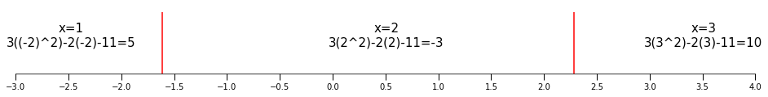

$$for 3x^{2}-2x-11>0$$

$$x<\frac{1-\sqrt{34}}{3} \& \frac{1+\sqrt{34}}{3}<x$$

$$\left(-∞, \frac{1-\sqrt{34}}{3}\right) \& \left(\frac{1+\sqrt{34}}{3}, ∞\right)$$

$$Rational Inequalities$$
$$PDF Pg. 141$$
- $\frac{x+1}{x-5}≤0$
$$\frac{x+1}{x-5}≤0$$

$$finding the roots$$
$$x+1=0$$
$$x=-1$$

$$finding the undefined points$$
$$x-5=0$$
$$x=5$$

$$test cases$$
$$x_{1}=-2$$
$$\frac{\left(-2\right)+1}{\left(-2\right)-5}=$$
$$\frac{-1}{-7}=\frac{1}{7}$$

$$x_{2}=2$$
$$\frac{\left(2\right)+1}{\left(2\right)-5}=$$
$$\frac{3}{-3}=-1$$

$$x_{3}=6$$
$$\frac{\left(6\right)+1}{\left(6\right)-5}=$$
$$\frac{7}{1}=7$$
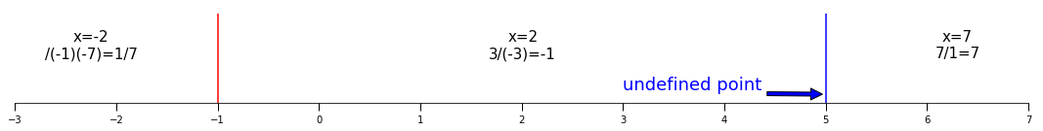

$$for \frac{x+1}{x-5}≤0$$
$$-1≤x<5$$
$$[-1, 5)$$

- $\frac{x^{2}+4x+3}{x-1}>0$
$$\frac{x^{2}+4x+3}{x-1}>0$$
$$\frac{\left(x+1\right)\left(x+3\right)}{x-1}>0$$
$$finding the roots$$
$x+1=0$ $x+3=0$
$x=-1$ $x=-3$
$$finding the undefined points$$
$$x-1=0$$
$$x=1$$
$$test cases$$
$$x_{1}=-4$$
$$\frac{\left(\left(-4\right)+1\right)\left(\left(-4\right)+3\right)}{\left(-4\right)-1}=$$
$$\frac{\left(-3\right)\left(-1\right)}{\left(-5\right)}=$$
$$\frac{3}{-5}=-\frac{3}{5}$$

$$x_{2}=-2$$
$$\frac{\left(\left(-2\right)+1\right)\left(\left(-2\right)+3\right)}{\left(-2\right)-1}=$$
$$\frac{\left(-1\right)\left(1\right)}{-3}=$$
$$\frac{-1}{-3}=\frac{1}{3}$$

$$x_{3}=0$$
$$\frac{\left(\left(0\right)+1\right)\left(\left(0\right)+3\right)}{\left(0\right)-1}=$$
$$\frac{\left(1\right)\left(3\right)}{-1}=$$
$$\frac{3}{-1}=-3$$

$$x_{4}=2$$
$$\frac{\left(\left(2\right)+1\right)\left(\left(2\right)+3\right)}{\left(2\right)-1}=$$
$$\frac{\left(3\right)\left(5\right)}{1}=$$
$$\frac{15}{1}=15$$

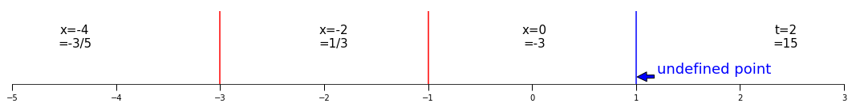

$$for\frac{\left(x+1\right)\left(x+3\right)}{x-1}>0$$
$$-3<x<-1 \& 1<x$$
$$\left(-3, -1\right) \& \left(1,∞\right)$$

- $\frac{x^{2}-16}{{\left(x-1\right)}^{2}}<0$
$$\frac{x^{2}-16}{{\left(x-1\right)}^{2}}<0$$
$$\frac{\left(x-4\right)\left(x+4\right)}{{\left(x-1\right)}^{2}}<0$$
$$finding the roots$$
$x-4=0$ $x+4=0$
$x=4$ $x=-4$
$$finding the undefined points$$
$$x-1=0$$
$$x=1$$
$$test cases$$
$$x_{1}=-5$$
$$\frac{\left(\left(-5\right)-4\right)\left(\left(-5\right)+4\right)}{\left(\left(-5\right)-1\right)\left(\left(-5\right)-1\right)}=$$
$$\frac{\left(-9\right)\left(-1\right)}{\left(-6\right)\left(-6\right)}=$$
$$\frac{9}{36}=\frac{1}{4}$$

$$x_{2}=-2$$
$$\frac{\left(\left(-2\right)-4\right)\left(\left(-2\right)+4\right)}{\left(\left(-2\right)-1\right)\left(\left(-2\right)-1\right)}=$$
$$\frac{\left(-6\right)\left(2\right)}{\left(-3\right)\left(-3\right)}=$$
$$\frac{-12}{9}=-\frac{4}{3}$$

$$x_{3}=2$$
$$\frac{\left(\left(2\right)-4\right)\left(\left(2\right)+4\right)}{\left(\left(2\right)-1\right)\left(\left(2\right)-1\right)}=$$
$$\frac{\left(-2\right)\left(6\right)}{\left(1\right)\left(1\right)}=$$
$$\frac{-12}{1}=-12$$

$$x_{4}=5$$
$$\frac{\left(\left(5\right)-4\right)\left(\left(5\right)+4\right)}{\left(\left(5\right)-1\right)\left(\left(5\right)-1\right)}=$$
$$\frac{\left(1\right)\left(9\right)}{\left(4\right)\left(4\right)}=\frac{9}{16}$$

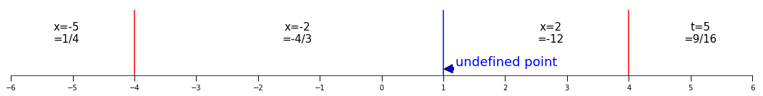

$$\frac{\left(x-4\right)\left(x+4\right)}{{\left(x-1\right)}^{2}}<0$$
$$-4<x<1 \& 1<x<4$$
$$\left(-4, 1\right) \& (1, 4)$$

- $\frac{3x+1}{x+4}≥1$
$$\frac{3x+1}{x+4}≥1$$
$$\frac{3x+1}{x+4}-1≥0$$
$$\frac{3x+1}{x+4}-\frac{x+4}{x+4}≥0$$
$$\frac{3x+1-\left(x+4\right)}{x+4}≥0$$
$$\frac{3x+1-x-4}{x+4}≥0$$
$$\frac{2x-3}{x+4}≥0$$

$$finding the roots$$
$$2x-3=0$$
$$2x=3$$
$$x=\frac{3}{2}$$

$$finding the undifined points$$
$$x+4=0$$
$$x=-4$$

$$test cases$$
$$x_{1}=-5$$
$$\frac{2\left(-5\right)-3}{\left(-5\right)+4}=$$
$$\frac{-10-3}{-1}=$$
$$\frac{-13}{-1}=13$$

$$x_{2}=0$$
$$\frac{2\left(0\right)-3}{\left(0\right)+4}=$$
$$\frac{-3}{4}=-\frac{3}{4}$$

$$x_{3}=2$$
$$\frac{2\left(2\right)-3}{\left(2\right)+4}=$$
$$\frac{4-3}{6}=\frac{1}{6}$$

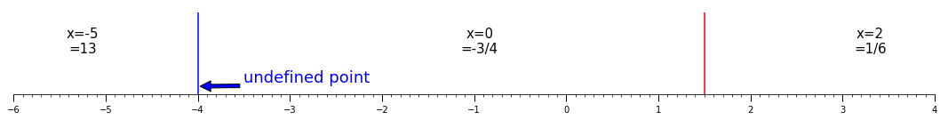
$$\frac{2x-3}{x+4}≥0$$
$$x<-4 \& \frac{3}{2}≤x$$
$$\left(-∞, -4\right) \& [\frac{3}{2}, ∞)$$

- $\frac{x-8}{x}≤3-x$
$$\frac{x-8}{x}≤3-x$$
$$\frac{x-8}{x}+x-3≤0$$
$$\frac{x-8}{x}+\frac{x\left(x-3\right)}{x}≤0$$
$$\frac{x-8}{x}+\frac{x^{2}-3x}{x}≤0$$
$$\frac{x^{2}+2x-8}{x}≤0$$
$$\frac{\left(x+4\right)\left(x-2\right)}{x}≤0$$
$$finding the roots$$
$x+4=0$ $x-2=0$
$x=-4$ $x=2$
$$finding the undefined values$$
$$x=0$$

$$test cases$$
$$x_{1}=-5$$
$$\frac{\left(\left(-5\right)+4\right)\left(\left(-5\right)-2\right)}{-5}=$$
$$\frac{\left(-1\right)\left(-7\right)}{-5}=$$
$$\frac{7}{-5}=-\frac{7}{5}$$

$$x_{2}=-1$$
$$\frac{\left(\left(-1\right)+4\right)\left(\left(-1\right)-2\right)}{-1}=$$
$$\frac{\left(3\right)\left(-3\right)}{-1}=$$
$$\frac{-9}{-1}=9$$

$$x_{3}=1$$
$$\frac{\left(\left(1\right)+4\right)\left(\left(1\right)-2\right)}{1}=$$
$$\frac{\left(5\right)\left(-1\right)}{1}=-5$$

$$x_{4}=3$$
$$\frac{\left(\left(3\right)+4\right)\left(\left(3\right)-2\right)}{3}=$$
$$\frac{\left(7\right)\left(1\right)}{3}=\frac{7}{3}$$
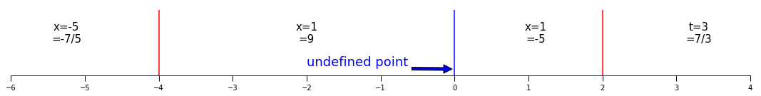
$$for \frac{\left(x+4\right)\left(x-2\right)}{x}≤0$$
$$x≤-4 \& 0<x≥2$$
$$\left(-∞, -4\right] \& (0, 2]$$

$$Absolute Value Equations$$
$$PDF Pg. 141$$

  - $\left|2x-5\right|=9$
$$\left|2x-5\right|=9$$
$\left|2x-5\right|=-9$ $\left|2x-5\right|=9$
$2x-5=-9$ $2x-5=9$
$2x=-4$ $2x=14$
$x=-\frac{4}{2}$ $x=\frac{14}{2}$

$x=-2$ or $x=7$

  - $\left|1-3t\right|=20$
$$\left|1-3t\right|=20$$
$1-3t=20$ $1-3t=-20$
$-3t=19$ $-3t=-21$
$t=-\frac{19}{3}$ $t=\frac{-21}{-3}$

$t=-\frac{19}{3}$ $t=7$

  - $\left|5y-8\right|=1$
$$\left|5y-8\right|=1$$
$5y-8=1$ $5y-8=-1$
$5y=9$ $5y=7$

$y=\frac{9}{5}$ $y=\frac{7}{5}$

  - $\left|10x-3\right|=0$
$$\left|10x-3\right|=0$$
$$10x-3=$$
$$10x=3$$
$$x=\frac{3}{10}$$

  - $\left|5x-9\right|=-3$
$$\left|5x-9\right|=-3$$
$$no solution$$

  - $\left|x-2\right|=3x+1$
$$\left|x-2\right|=3x+1$$
$x-2=3x+1$ $x-2=-\left(3x+1\right)$
$x-2=3x+1$ $x-2=-3x-1$
$x-2-1=3x$ $x-2+1=-3x$
$x-3=3x$ $x-1=-3x$
$-3=3x-x$ $-1=-3x-x$
$-3=2x$ $-1=-4x$
$-\frac{3}{2}=x$ $\frac{-1}{-4}=x$
$\frac{1}{4}=x$

$$test cases$$
$\left|\left(-\frac{3}{2}\right)-2\right|=3\left(-\frac{3}{2}\right)+1$ $\left|\left(\frac{1}{4}\right)-2\right|=3\left(\frac{1}{4}\right)+1$
$\left|-\frac{3}{2}-\frac{4}{2}\right|=-\frac{9}{2}+\frac{2}{2}$ $\left|\frac{1}{4}-\frac{8}{4}\right|=\frac{3}{4}+\frac{4}{4}$
$\left|-\frac{7}{2}\right|=-\frac{7}{2}$ $\left|-\frac{7}{4}\right|=\frac{7}{4}$
$\frac{7}{2}≠-\frac{7}{2}$ $\frac{7}{4}=\frac{7}{4}$

  - $\left|4x+3\right|=3-x$
$$\left|4x+3\right|=3-x$$
$4x-3=-\left(3-x\right)$ $4x-3=3-x$
$4x-3=-3+x$ $4x=3+3-x$
$4x=-3+3+x$ $4x-x=6$
$4x=0-x$ $3x=6$
$4x+x=0$ $x=\frac{6}{3}$
$x=0$ $x=2$
$$test cases$$
$\left|4\left(0\right)+3\right|=3-0$ $\left|4\left(2\right)+3\right|=3-2$
$\left|0+3\right|=3$ $\left|8+3\right|=1$
$3=3$ $\left|11\right|=1$
$11≠1$

  - $\left|2x-1\right|=\left|4x+9\right|$
$$\left|2x-1\right|=\left|4x+9\right|$$
$2x-1=4x+9$ $-\left(2x-1\right)=-\left(4x+9\right)$
$2x-1-9=4x$ $-2x+1=-4x-9$
$2x-10=4x$ $-2x+1+9=-4x$
$-10=4x-2x$ $-2x+10=-4x$
$-10=2x$ $10=-4x+2x$
$\frac{-10}{2}=x$ $10=-2x$
$-5=x$ $\frac{10}{-2}=x$
$-5=x$

$-\left(2x-1\right)=4x+9$ $2x-1=-\left(4x+9\right)$
$-2x+1=4x+9$ $2x-1=-4x-9$
$-2x-4x=9-1$
$-6x=8$
$x=\frac{8}{-6}$
$x=-\frac{4}{3}$

$$test cases$$
$\left|2x-1\right|=\left|4x+9\right|$ $\left|2x-1\right|=\left|4x+9\right|$
$\left|2\left(-\frac{4}{3}\right)-1\right|=\left|4\left(-\frac{4}{3}\right)+9\right|$ $\left|2\left(-5\right)-1\right|=\left|4\left(-5\right)+9\right|$
$\left|-\frac{8}{3}-\frac{3}{3}\right|=\left|-\frac{16}{3}+\frac{27}{3}\right|$ $\left|-10-1\right|=\left|-20+9\right|$
$\left|-\frac{11}{3}\right|=\left|\frac{11}{3}\right|$ $\left|-11\right|=\left|-11\right|$
$\frac{11}{3}=\frac{11}{3}$ $11=11$

$$Absolute Value Inequalities$$
$$PDF Pg. 152$$

  - $\left|2x-4\right|<10$
$$\left|2x-4\right|<10$$
$$-10<2x-4<10$$
$$-10+4<2x<10+4$$
$$-6<2x<14$$
$$\frac{-6}{2}<x<\frac{14}{2}$$
$$-3<x<7$$
$$\left(-3, 7\right)$$

  - $\left|9m+2\right|≤1$
$$\left|9m+2\right|≤1$$
$$-1≤9m+2≤1$$
$$-1-2≤9m≤1-2$$
$$-3≤9m≤-1$$
$$-\frac{3}{9}≤m≤-\frac{1}{9}$$
$$-\frac{1}{3}≤m≤-\frac{1}{9}$$

  - $\left|3-2z\right|≤5$
$$\left|3-2z\right|≤5$$
$$-5≤3-2z≤5$$
$$-5-3≤-2z≤5-3$$
$$-8≤-2z≤2$$
$$\frac{-8}{-2}≥z≥\frac{2}{-2}$$
$$-1≤z≤4$$
$$\left[-1, 4\right]$$

  - $\left|2x-3\right|>7$
$$\left|2x-3\right|>7$$
$2x-3<-7$ $7<2x-3$
$2x<-7+3$ $7+3<2x$
$2x<-4$ $10<2x$
$x<-\frac{4}{2}$ $\frac{10}{2}<x$
$x<-\frac{1}{2}$ $5<x$

$$x<-2 or 5<x$$
$$\left(-∞, 2\right) or (5, ∞)$$

  - $\left|6t+10\right|≥3$
$$\left|6t+10\right|≥3$$
$6t+10≤-3$ $3≤6t+10$
$6t≤-3-10$ $3-10≤6t$
$6t≤-13$ $-7≤6t$
$t≤-\frac{13}{6}$ $-\frac{7}{6}≤t$
$$t≤-\frac{13}{6} or -\frac{7}{6}≤t$$
$$\left(-∞, -\frac{13}{6}\right] or [-\frac{7}{6}, ∞)$$

  - $\left|2-6y\right|>10$
$$\left|2-6y\right|>10$$
$2-6y<-10$ $10<2-6y$
$-6y<-10-2$ $10-2<-6y$
$-6y<-12$ $8<-6y$
$y>\frac{-12}{-6}$ $\frac{8}{-6}>y$
$y>2$ $-\frac{4}{3}>y$
$$y<-\frac{4}{3} or 2<y$$
$$\left(-∞, -\frac{4}{3}\right) or \left(2, ∞\right)$$

  - $\left|3x+2\right|<0$
$$\left|3x+2\right|<0$$
$$no solution because absolute value cannot be less than 0$$

  - $\left|x-9\right|≤0$
$$\left|x-9\right|=0$$
$$x-9=0$$
$$x=9 and only 9 because absolute value cannot be less than 0$$

  - $\left|2x-4\right|≥0$
$$\left|2x-4\right|≥0$$
$$all real numbers$$

  - $\left|3x-9\right|>0$
$$\left|3x-9\right|>0$$
$$0<3x-9$$
$$9<3x$$
$$\frac{9}{3}<x$$
$$3<x$$
$$all real numbers except 3, becuase \left|3\left(3\right)-9\right|=0$$

  - $\left|4x+15\right|<-2 and \left|4x+15\right|≤-2$
$$no solution$$

  - $\left|2x-9\right|≥-8 and \left|2x-9\right|>-8$

$$Graphing and Functions$$
$$PDF Pg. 158$$
Example 1, Sketch the graph of $y={\left(x-1\right)}^{2}-4$
x-intercept
$$0={\left(x-1\right)}^{2}-4$$
$$4={\left(x-1\right)}^{2}$$
$$\sqrt{4}=\sqrt{{\left(x-1\right)}^{2}}$$
$$2=x-1 or-\left(x-1\right)$$
$2=x-1$ $2=-\left(x-1\right)$
$3=x$ $2=-x+1$
$1=-x$
$-1=x$
$\left(3, 0\right)$ $\left(-1, 0\right)$
y-intercepts
$$y={\left(0-1\right)}^{2}-4$$
$$y={\left(-1\right)}^{2}-4$$
$$y=1-4$$
$$y=-3$$
$$\left(0, -3\right)$$
graphed points
(-1, 0.0)
(0, -3.0)
(1, -4.0)
(2, -3.0)
(3, 0.0)
(4, 5.0)

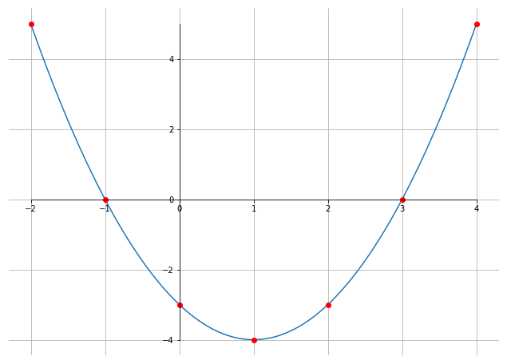

Example 2
- Sketch the graph of $y=x^{2}+x-6$
x intercepts
$$0=x^{2}+x-6$$
$$0=\left(x-2\right)\left(x+3\right)$$
$$0=\left(x-2\right) or 0=\left(x+3\right)$$
$0=x-2$ $0=x+3$
$x=2$ $x=-3$
$\left(0, 2\right)$ $\left(0, -3\right)$

y intercepts

$$y=0^{2}+0-6$$
$$y=-6$$
$$\left(0, -6\right)$$
Graphed points
(-4, 6)
(-3, 0.0)
(-2, -4.0)
(-1, -6.0)
(0, -6.0)
(1, -4.0)
(2, 0.0)
(3, 6.0)

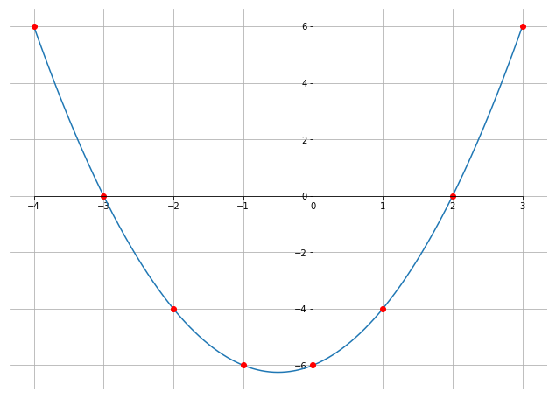

b. Sketch the graph of $y=x^{2}+2$
x intercepts
$$0=x^{2}+2$$
$$-2=x^{2}$$
$$\sqrt{-2}=\sqrt{x^{2}}$$
$$\sqrt{2}\left(i\right)=x or-x$$
$x=\sqrt{2}\left(i\right)$ $-x=\sqrt{2}\left(i\right)$
$x=-\sqrt{2}\left(i\right)$
$\left(\sqrt{2}\left(i\right), 0\right)$ $\left(-\sqrt{2}\left(i\right), 0\right)$
y intercepts
$$y=0^{2}+2$$
$$y=2$$
$$\left(0, 2\right)$$
graphed points
(-3, 11.0)
(-2, 6.0)
(-1, 3.0)
(0, 2.0)
(1, 3.0)
(2, 6.0)
(3, 11.0)

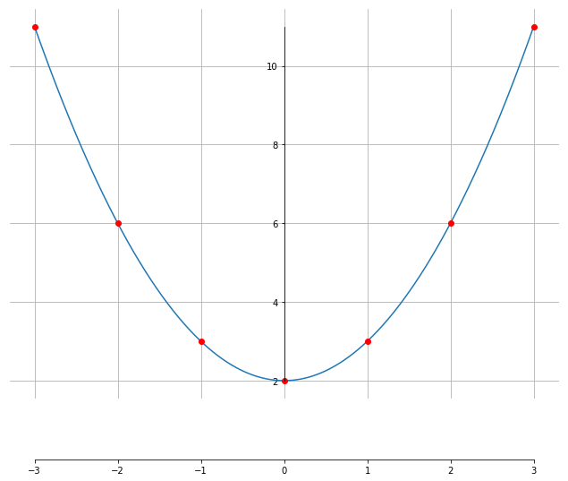

c. Sketch the graph of $y= {\left(x+1\right)}^{2}$
x intercepts
$$y= {\left(x+1\right)}^{2}$$
$$0={\left(x+1\right)}^{2}$$
$$0=\left(x+1\right)\left(x+1\right)$$
$$0=x+1$$
$$-1=x$$
$$\left(-1, 0\right)$$
y intercepts
$$y={\left(x+1\right)}^{2}$$
$$y={\left(0+1\right)}^{2}$$
$$y={\left(1\right)}^{2}$$
$$y=1$$
$$\left(0, 1\right)$$
Graphed points
(-3, 4.0)
(-2, 1.0)
(-1, 0.0)
(0, 1.0)
(1, 4.0)
(2, 9.0)
(-4, 9.0)
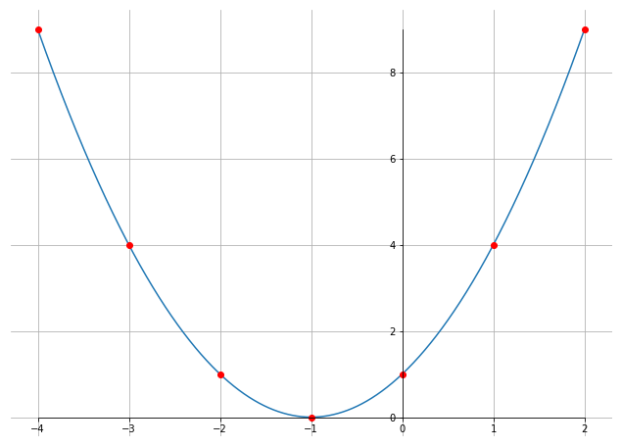

Lines
Standard form:
$$Ax+By=C$$
Slope equation
$$m=\frac{y_{1}-y_{2}}{x_{1}-x_{2}}$$
Point slope form
$$y_{1}-y_{2}=m\left(x_{1}-x_{2}\right)$$
Or
$$y_{1}=y_{2}+m\left(x_{1}-x_{2}\right)$$
Slope intercept form
$$y=mx+b$$

Example 1, find the slope and draw a graph for each of the following
- Line through points $\left(-2, -3\right)$ and $\left(3, 1\right)$
$$m=\frac{y_{1}-y_{2}}{x_{1}-x_{2}}$$
$$m=\frac{\left(-3\right)-\left(1\right)}{\left(-2\right)-\left(3\right)}$$
$$m=\frac{-4}{-5}$$
$$m=\frac{4}{5}$$

$$y_{1}=y_{2}+m\left(x_{1}-x_{2}\right)$$
$$y=1+\frac{4}{5}\left(x-3\right)$$
$$y=\frac{9}{5}\left(x-3\right)$$
$$y=1+\frac{4}{5}x-\frac{4}{5}\left(3\right)$$
$$y=\frac{9}{5}x-\frac{12}{5}$$
Minimum y is (-3.0, -7.800000000000001)
Maximum of y is (3.0, 3.0000000000000004)

(0, -2.4)
(-2, -6.0)
(3, 3.0000000000000004)

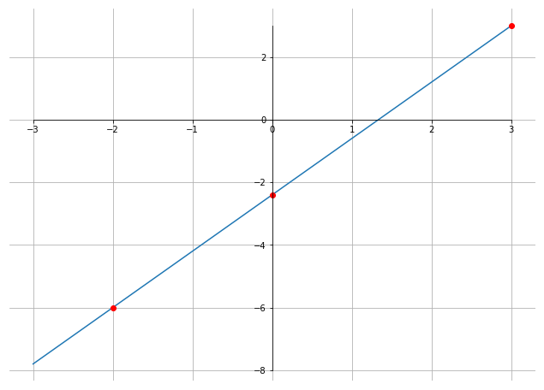

- Line through points $\left(-1, 5\right)$ and $\left(0, -2\right)$
$$m=\frac{y_{1}-y_{2}}{x_{1}-x_{2}}$$
$$m=\frac{5-\left(-2\right)}{\left(-1\right)-\left(0\right)}$$
$$m=\frac{7}{-1}$$
$$m=-7$$

$$y_{1}=y_{2}+m\left(x_{1}-x_{2}\right)$$
$$y_{1}=\left(-2\right)+\left(-7\right)\left(x-0\right)$$
$$y=-2+\left(-7x\right)$$
$$y=-2-7x$$
$$y=-7x-2$$

Minimum y is (3.0, -23.0)
Maximum of y is (-3.0, 19.0)

(0, -2.0)
(-1, 5.0)
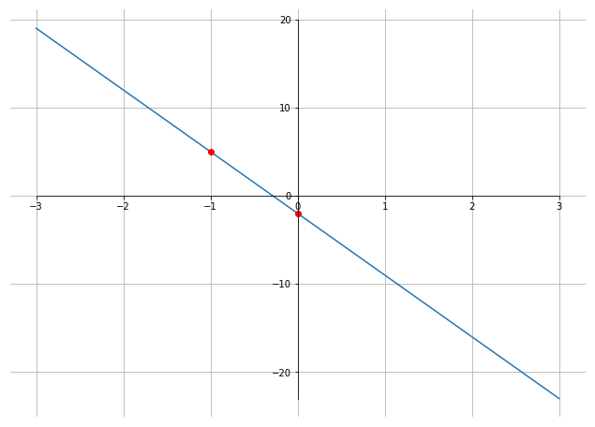

- Line through points $\left(-3, 2\right)$ and $\left(5, 2\right)$
$$m=\frac{y_{1}-y_{2}}{x_{1}-x_{2}}$$
$$m=\frac{2-2}{-3-5}$$
$$m=\frac{0}{-8}$$
$$m=0$$

$$y_{1}=y_{2}+m\left(x_{1}-x_{2}\right)$$
$$y=2+0\left(-3-5\right)$$
$$y=2$$
Minimum y is (-4.0, 2.0)
Maximum of y is (-4.0, 2.0)
(0, 2.0)
(5, 2.0)
(-3, 2.0)
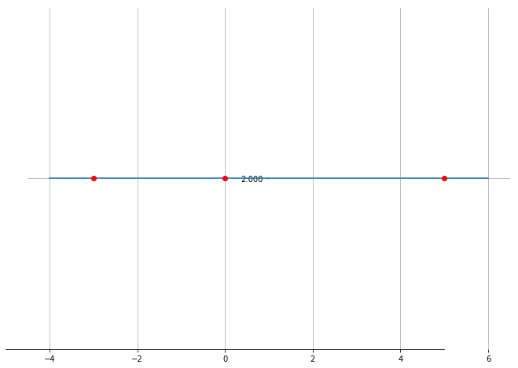

- Line through points $\left(4, 3\right)$ and $\left(4, -2\right)$
$$m=\frac{y_{1}-y_{2}}{x_{1}-x_{2}}$$
$$m=\frac{3-\left(-2\right)}{4-4}$$
$$m=\frac{5}{0}$$
$$m=undefined$$

$$y_{1}=y_{2}+m\left(x_{1}-x_{2}\right)$$
$$y=y$$
$$x=4$$

Example 2, determine the equation for the line passing through $\left(-2, 4\right) and \left(3, -5\right)$
$$m=\frac{y_{1}-y_{2}}{x_{1}-x_{2}}$$
$$m=\frac{4-\left(-5\right)}{\left(-2\right)-\left(3\right)}$$
$$m=\frac{1}{-5}$$
$$m=-\frac{1}{5}$$

$$y=3-\frac{1}{5}\left(x-3\right)$$
$$y=3-\frac{x}{5}+\frac{3}{5}$$
$$y=-\frac{x}{5}+3+\frac{3}{5}$$
$$y=-\frac{1}{5}x+\frac{15}{5}+\frac{3}{5}$$
$$y=-\frac{1}{5}x+\frac{18}{5}$$
Minimum y is (8.0, 2.0)
Maximum of y is (-8.0, 5.2)

(0, 3.6)
(3, 3.0)
(-2, 4.0)

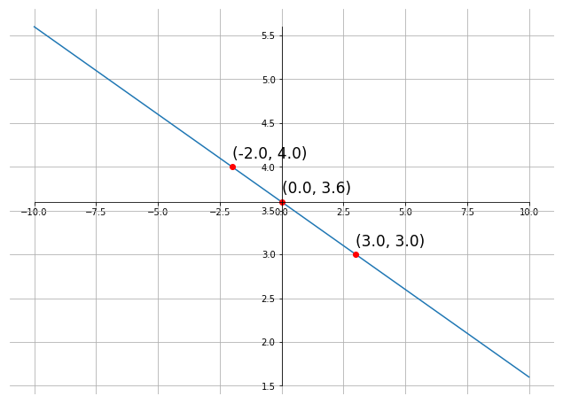

Example 3, Determine the slope and the sketch the graph of the following functions
- $2y-6x=-2$
$$2y=-2+6x$$
$$y=\frac{-2+6x}{2}$$
$$y=-1+3x$$
$$y=3x-1$$
$$m=3$$
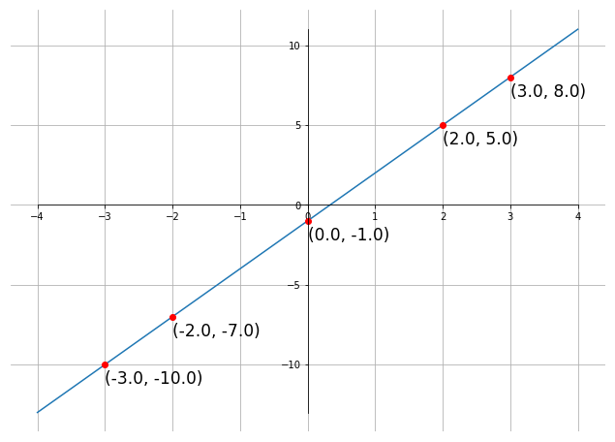

- $3y+4x=6$
$$3y+4x=6$$
$$3y=-4x+6$$
$$y=-\frac{4}{3}x+\frac{6}{3}$$
$$y=-\frac{4}{3}x+2$$
$$m=-\frac{4}{3}$$
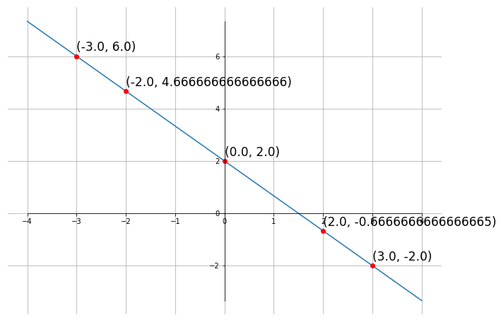

Parallel and perpendicular lines
Slope of parallel lines is $m_{1}=m_{2}$
Slope of perpendicular lines $m_{1}*m_{2}=-1$ or $m_{2}=-\frac{1}{m_{1}}$
Example 4, Determine if the line that passes through points $\left(-2, -10\right) and \left(6, -1\right)$ is parallel, perpendicular, or neither to the line $7y-9x=15$
$$for f^{1}$$
$$m=\frac{y-y}{x-x}$$
$$m=\frac{-10-\left(-1\right)}{-2-6}$$
$$m=\frac{-9}{-8}$$
$$m=\frac{9}{8}$$
$$y-y=m\left(x-x\right) for points \left(-2, -10\right) and \left(6, -1\right)$$
$$y-\left(-1\right)=m(x-6)$$
$$y=-1+\frac{9}{8}\left(x-6\right)$$
$$y=-1+\frac{9}{8}x-\frac{54}{8}$$
$$y=\frac{9}{8}x-1-\frac{27}{4}$$
$$y=\frac{9}{8}x-\frac{4}{4}-\frac{27}{4}$$
$$y=\frac{9}{8}x-\frac{31}{4}$$

$$for f^{2}$$
$$y=mx+b$$
$$7y-9x=15$$
$$7y=9x+15$$
$$y=\frac{9}{7}x+\frac{15}{7}$$
$$m=\frac{9}{7}$$

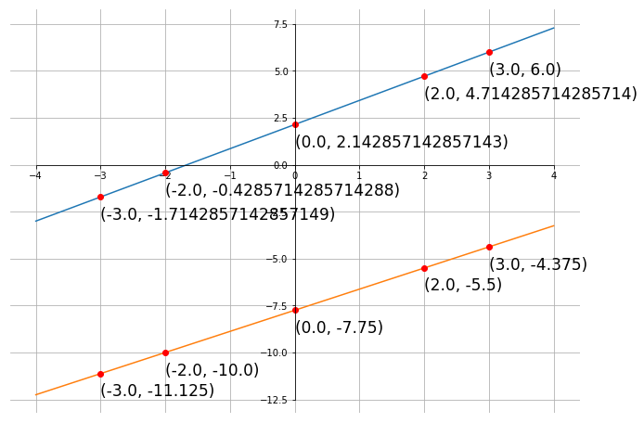

Example 5, Determine the equation of the line that passes through the point $\left(8, 2\right)$ and is
- Parallel to the line $10y=-3x-2$
$$finding the slope$$
$$10y=-3x-2$$
$$y=\frac{-3x-2}{10}$$
$$y=-\frac{3}{10}x-\frac{2}{10}$$
$$y=-\frac{3}{10}x-\frac{1}{5}$$

$$finding parallel line through point\left(8, 2\right)$$
$$y=y+m\left(x-x\right)$$
$$y=2+\left(-\frac{3}{10}\right)\left(x-8\right)$$
$$y=2-\frac{3}{10}x+\frac{24}{10}$$
$$y=-\frac{3}{10}x+2+\frac{12}{5}$$
$$y=-\frac{3}{10}x+\frac{10}{5}+\frac{12}{5}$$
$$y=-\frac{3}{10}x+\frac{22}{5}$$

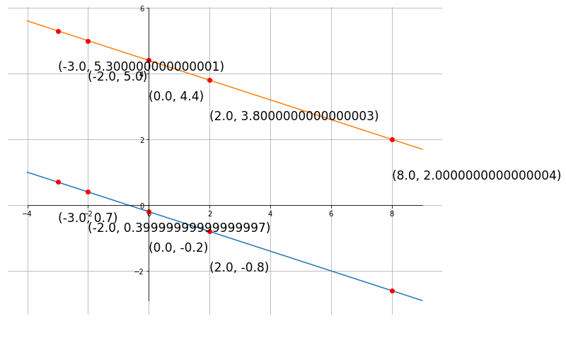

- Perpendicular to the line 10y+3x=-2
$$finding the slope$$
$$10y+3x=-2$$
$$10y=-3x-2$$
$$y=\frac{-3x-2}{10}$$
$$y=-\frac{3}{10}x-\frac{1}{5}$$

$$finding perpindicular slope$$
$$\frac{-3}{10}m^{1}=-1$$
$$m^{1}=\frac{10}{-3}\left(-1\right)$$
$$m^{1}=\frac{-10}{-3}$$
$$m^{1}=\frac{10}{3}$$
$$finding perpindicular line through point (8, 2)$$
$$y-y=m\left(x-x\right)$$
$$y=y+m\left(x-x\right)$$
$$y=2+\frac{10}{3}\left(x-8\right)$$
$$y=2+\frac{10}{3}x-\left(\frac{10}{3}\right)\left(8\right)$$
$$y=2+\frac{10}{3}x-\left(\frac{80}{3}\right)$$
$$y=\frac{10}{3}x-\frac{74}{3}$$

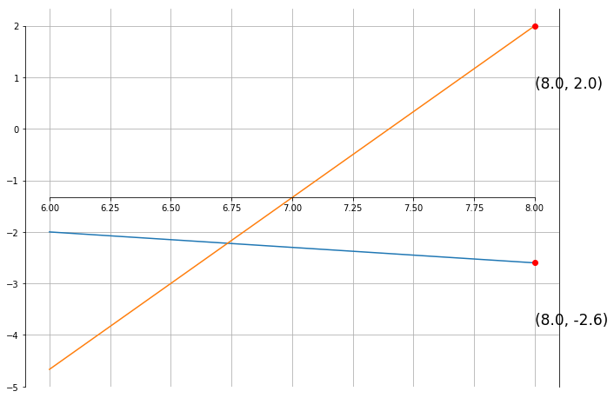

Circles
Example 1
Find the equation of a circle with radius 8 and center $\left(-4, 7\right)$ and graph
$$r^{2}={\left(x-h\right)}^{2}+{\left(y-k\right)}^{2}$$
$$8^{2}={\left(x-\left(-4\right)\right)}^{2}+{\left(y-7\right)}^{2}$$
$${64=\left(x+4\right)}^{2}+{\left(y-7\right)}^{2}$$
Right most point = $\left(h+r, k\right)$
$$\left(-4+8, 7\right)$$
$$\left(4, 7\right)$$
Left most point = $\left(h-r, k\right)$
$$\left(-4-8, 7\right)$$
$$\left(-12, 7\right)$$
Top most point = $\left(h, k+r\right)$
$$\left(-4, 7+8\right)$$
$$\left(-4, 15\right)$$
Bottom most point = $\left(h, k-r\right)$
$$\left(-4, 7-8\right)$$
$$\left(-4, -1\right)$$

Example 2
Find the center and radius of each circle and graph
- $x^{2}+y^{2}=1$
$$r^{2}={\left(x-h\right)}^{2}+{\left(y-k\right)}^{2}$$
$$1^{2}={\left(x-h\right)}^{2}+{\left(x-k\right)}^{2}$$
$$1={\left(x-0\right)}^{2}+{\left(x-0\right)}^{2}$$
$$1=x^{2}+y^{2}$$
$$center is \left(0, 0\right)$$
$$radius is 1$$
Right most point = $\left(h+r, k\right)$
$$\left(0+1, 0\right)$$
$$\left(1, 0\right)$$
Left most point = $\left(h-r, k\right)$
$$\left(0-1, 0 \right)$$
$$\left(-1, 0\right)$$
Top most point = $\left(h, k+r\right)$
$$\left(0, 0+1\right)$$
$$\left(0, 1\right)$$
Bottom most point = $\left(h, k-r\right)$
$$\left(0, 0-1\right)$$
$$\left(0, -1\right)$$

$$for the computers$$
$$1^{2}=x^{2}+y^{2}$$
$$y^{2}=x^{2}-1^{2}$$
$$y=\sqrt{x^{2}-1}$$

- $x^{2}+{\left(y-3\right)}^{2}=4$
$$r^{2}={\left(x-h\right)}^{2}+{\left(y-k\right)}^{2}$$
$$4=x^{2}+{\left(y-3\right)}^{2}$$
$$4=x^{2}+{\left(y-3\right)}^{2}$$
$$\sqrt{4}=\sqrt{x^{2}+{\left(y-3\right)}^{2}}$$
$$2=\sqrt{x^{2}+{\left(y-3\right)}^{2}}$$
$$radius=2$$
$$center= \left(0, 3\right)$$

Right most point = $\left(h+r, k\right)$
$$\left(0+2, 3\right)$$
$$\left(2, 3\right)$$
Left most point = $\left(h-r, k\right)$
$$\left(0-2, 3\right)$$
$$\left(-2, 3\right)$$
Top most point = $\left(h, k+r\right)$
$$\left(0, 3+2\right)$$
$$\left(0, 5\right)$$
Bottom most point = $\left(h, k-r\right)$
$$\left(0, 3-2\right)$$
$$\left(0, 1\right)$$

- ${\left(x-1\right)}^{2}+{\left(y+4\right)}^{2}=16$
$$r^{2}={\left(x-h\right)}^{2}+{\left(y-k\right)}^{2}$$
$$16={\left(x-1\right)}^{2}+{\left(y+4\right)}^{2}$$
$$\sqrt{16}=\sqrt{{\left(x-1\right)}^{2}+{\left(y+4\right)}^{2}}$$
$$4=\sqrt{{\left(x-1\right)}^{2}+{\left(y+4\right)}^{2}}$$
$$radius=4$$
$$center= \left(1, -4\right)$$
Right most point = $\left(h+r, k\right)$
$$\left(1+4, -4 \right)$$
$$\left(5, -4\right)$$
Left most point = $\left(h-r, k\right)$
$$\left(1-4, -4\right)$$
$$\left(-3, -4\right)$$
Top most point = $\left(h, k+r\right)$
$$\left(1, -4+4\right)$$
$$\left(1, 0\right)$$
Bottom most point = $\left(h, k-r\right)$
$$\left(1, -4-4\right)$$
$$\left(1, -8\right)$$

Example 3
Determine the center and radius of each circle
- $x^{2}+y^{2}+8x+7=0$
$$r^{2}={\left(x-h\right)}^{2}+{\left(y-k\right)}^{2}$$
$$0=x^{2}+y^{2}+8x+7$$
$$-7=x^{2}+y^{2}+8x$$
$$-7=x^{2}+8x+y^{2}$$
$$finding the term to complete the square$$
$${\left(\frac{8}{2}\right)}^{2}=4^{2}=16$$
$$completeing the squre$$
$$-7+16=x^{2}+8x+{16+y}^{2}$$
$$9={\left(x+4\right)}^{2}+y^{2}$$
$$r^{2}={\left(x-h\right)}^{2}+{\left(y-k\right)}^{2}$$
$$\sqrt{9}=\sqrt{{\left(x+4\right)}^{2}+y^{2}}$$
$$3=\sqrt{{\left(x+4\right)}^{2}+y^{2}}$$
$$radius=3$$
$$center= \left(-4, 0\right)$$
Right most point = $\left(h+r, k\right)$
$$\left(-4+3, 0\right)$$
$$\left(-1, 0\right)$$
Left most point = $\left(h-r, k\right)$
$$\left(-4-3, 0\right)$$
$$\left(-7, 0\right)$$
Top most point = $\left(h, k+r\right)$
$$\left(-4, 0+3\right)$$
$$\left(-4, 3\right)$$
Bottom most point = $\left(h, k-r\right)$
$$\left(-4, 0-3\right)$$
$$\left(-4, -3\right)$$

- $x^{2}+y^{2}-3x+10y-1=0$
$$0=x^{2}+y^{2}-3x+10y-1$$
$$1=x^{2}+y^{2}-3x+10y$$
$$1=x^{2}-3x+y^{2}+10y$$
$$complete the square$$
$x^{2}-3x$ $y^{2}+10y$
${\left(-\frac{3}{2}\right)}^{2}$ ${\left(\frac{10}{5}\right)}^{2}$
${\left(\frac{-3}{2}\right)}^{2}$ $5^{2}$
$\frac{9}{4}$ 25
$$1+\frac{9}{4}+25=x^{2}-3x+\frac{9}{4}+y^{2}+10y+25$$
$$\frac{4}{4}+\frac{9}{4}+\frac{100}{4}={\left(x-\frac{3}{2}\right)}^{2}+{\left(y+5\right)}^{2}$$
$$\frac{113}{4}={\left(x-\frac{3}{2}\right)}^{2}+{\left(y+5\right)}^{2}$$
$$\sqrt{\frac{113}{4}}=\sqrt{\left(x-\frac{3}{2}\right)+\left(y+5\right)}$$
$$\frac{\sqrt{113}}{\sqrt{4}}=\frac{\sqrt{113}}{2}=r$$
$$center=\left(\frac{3}{2}, -5\right)$$
$$radius= \frac{\sqrt{113}}{2}$$

The Definition of a Function
PDF page 181
Example 1
What are the members of the following relation?
{$\left(-1, 0\right) \left(0, -3\right) \left(2, -3\right) \left(3, 0\right) \left(4, 5\right)\}$
$$1^{st}components: \left\{-1, 0, 2, 3, 4\right\}$$
$$2^{nd} components: \left\{0, -3, 0, 5\right\}$$

Example 2
Is the following a function? Why or why not?
{$\left(6, 10\right) \left(-7, 3\right) \left(0, 4\right) \left(6, 4\right) \}$
$$not a function as f\left(6\right) can equal either 10 or 4$$

Example 3
Determine if the following equations are functions or not;
a. $y=5x+1$
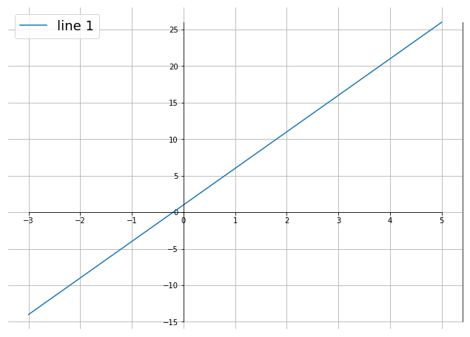
Since no value of single value of x produces more than one value of y, this is a function.

b. $y=x^{2}+1$
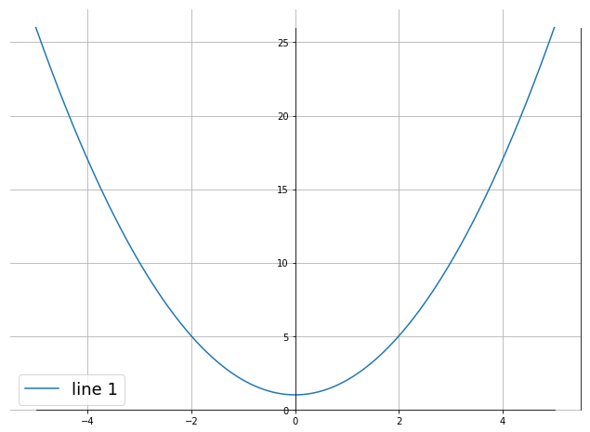
Since no value of single value of x produces more than one value of y, this is a function.

c. $y^{2}=x+1$
$$y^{2}=x+1$$
$$y=\sqrt{x+1}$$
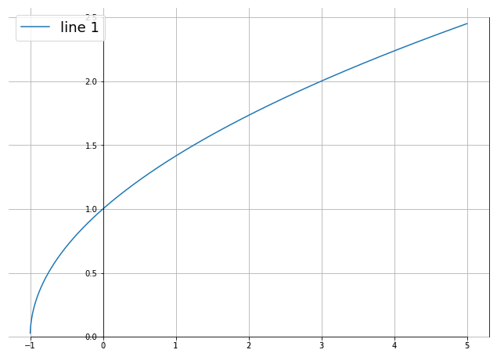
$$f\left(-5\right)=\sqrt{-5+1}$$
$$=\sqrt{-4}$$
$$=\sqrt{4\left(-1\right)}$$
$$=2i or -2i$$
Not a function

d. $x^{2}+y^{2}=4$
$$x^{2}+y^{2}=4$$
$$y^{2}=4-x^{2}$$
$$y=\sqrt{4-x^{2}}$$
$$y=\left(\sqrt{2-x}\right)\left(\sqrt{2+x}\right)$$

$$f\left(-5\right)=\sqrt{4-\left(-5\right)}$$
$$=\sqrt{4+5}$$
$$=\sqrt{9}$$
$$y=±3$$

$$f\left(4\right)=\sqrt{4-4}$$
$$=\sqrt{0}$$
$$y=0$$

$$f\left(0\right)=\sqrt{4-0}$$
$$=\sqrt{4}$$
$$=±2$$

Not a function

Example 4
Given $f\left(x\right)=x^{2}-2x+8$ and $g\left(x\right)=\sqrt{x+6}$, evaluate each of the following
a. $f\left(3\right) \& g\left(3\right)$
b. $f\left(-10\right) \& g\left(-10\right)$
c. $f\left(0\right)$
d. $f\left(t\right)$
e. $f\left(t+1\right) \& g\left(x+1\right)$
f. $f\left(x^{3}\right)$
g. $f\left(x^{2}-5\right)$

Example 5
Given, $f\left(x\right)=\left\{\begin{aligned}3t^{2}+4 if t≤-4 \\ 10 if -4<t≤15 \\ -16t if t>15\end{aligned}\right.$
Evaluate each of the following
a. $g\left(-6\right)$
b. $g\left(-4\right)$
c. $g\left(1\right)$
d. $g\left(15\right)$
e. $g\left(21\right)$

Example 6 Determine the domain of each of the following functions
a. $g\left(x\right)=\frac{x+3}{x^{2}+3x-10}$
b. $f\left(x\right)=\sqrt{5-3x}$
c. $h\left(x\right)=\frac{\sqrt{7x+8}}{x^{2}+4}$
d. $R\left(x\right)=\frac{\sqrt{10x-5}}{x^{2}-16}$

Graphing Functions
PDF Page 194

Example 1 Sketch the graph $f\left(x\right)={\left(x-1\right)}^{3}+1$
Example 2 Sketch the graph $g\left(x\right)=\left\{\begin{aligned}-x^{2}+4 if x<1 \\ 2x-1 if x≥1\end{aligned}\right.$
Example 3 Sketch the graph $h\left(x\right)=\left\{\begin{aligned}x+3 if x<-2 \\ x^{2} if -2≤x<1 \\ -x+2 if x≥1\end{aligned}\right.$

